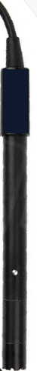
DO100 Benchtop DO Meter
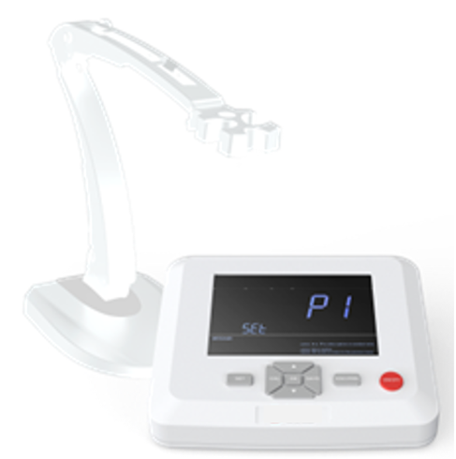

Features:
- High-resolution LCD display screen.
- With built-in microprocessor chip, automatic calibration, automatic temperature compensation, data storage, parameter setup, etc.
- Automatic calibration, self-diagnosis.
- Fast response, high accuracy, stable reading display.
- Calibration points: DO: 100% Oxygen or Zero oxygen calibration.
- Each kit comes with a polarographic type DO probe and 3pcs replaceable sensor caps.
- IP54 dustproof and spillproof.

Specifications:
DO | Range | 0-20.00 mg/L（ppm）, 0-200.0 %
DO | Accuracy/Resolution | ± 0.30 mg/L； 0.01 or 0.1 mg/L
DO | ATC range | （0 - 50）℃ automatically
DO | Salinity compensation | 0~45 ppt manual
DO | Barometric compensation | 0~200 kPa automatically
Temperature | Range | 0-100°C
Temperature | Resolution/Accuracy | 0.1℃; ±0.2℃
Data storage |  | 450groups
Data Output |  | - USB to Flash Disk  - Wireless connection to printer (the printer is optional)
Power supply |  | DC12V
Packing including |  | - DO100 Meter  - DO01-2M Polarographic DO probe, cable length: 2m  - DOS-01 Membrane refill solution: 30mL,1pc  - DOSC Sensor caps: 3pcs/group, 1pkg  - F01 Flexible probe Holder: 1pc  - A01 Power adaptor: 1pc

