**Pocket Testers**

**User Manual**



Please read operating manual before installation and operation.

**[Drawell International Technology Limited](http://www.drawell.com.cn/)**

**Chongqing Drawell Instrument Co., Ltd.**

**Shanghai Drawell Scientific Instrument Co.,Ltd.**

**Address** : Suite 2705,Building No.12,Shiyou Road No.1, Yuzhong District,

Chongqing China.

**Homepage** : [www.drawell.com.cn](http://www.drawell.com.cn/)

**Tel** : 0086-023-63268643

**Email** : [sales05@drawell.com.cn](mailto:sales01@drawell.com.cn)

* PH Pocket pH/mV Tester
* ORP Pocket ORP Tester
* COND Pocket Conductivity Tester
* PH/COND Pocket pH/Conductivity Tester



INDEX

1. Overview 3

1.1 Package content 3

1.2 Key features 3

2. Technical specifications 4

3. Descriptions 5

4. Before use 6

5. Installing the batteries 6

6. Setup programs 7

7. pH module 8

7.1 pH calibration 8

7.2 pH measurement 8

7.3 pH measurement notes 8

8. ORP module 9

8.1 ORP Measurement 9

8.2 ORP Measurement notes 9

9. Conductivity module 10

9.1. Conductivity calibration 10

9.2. Conductivity measurement 10

9.3. Conductivity measurement notes 10

10. Probe replacement 11

11. Warranty 11

Appendix：Troubleshooting 12

**NOTES**

* There is a small amount of deionized water in the electrode storage cap to keep the electrode sensitiveness, which is normal.
* The probe is designed with a polycarbonate plastic (PC) shell. PC plastic will dissolve in certain organic solvents, such as carbon tetrachloride, trichlorethylene, tetrahydrofuran, toluene, xylene and methylethyl ketone, etc. Should avoid test samples solution containing such solvents.

# Overview

Thank you for purchasing microprocessor-based waterproof pH/ EC / TDS / SALT tester with multi-color backlight display.

Be sure to read this manual before using the product to ensure proper and safe operation of the product. Also, safely store the manual so it is readily available whenever necessary. Product specifications and appearance as well as the contents of this manual are subject to change without notice.

## 1.1 Package content

|  |  |  |  |  |  |  |
| --- | --- | --- | --- | --- | --- | --- |
| **Model No.** | | | PH | ORP | COND | PH/COND |
| Test kit | 1 | Meter with pre-installed electrode | ✓ | ✓ | ✓ | ✓ |
| 2 | pH Buffer solution: 30mL pH4.00/7.00/10.01, one for each | ✓ | - | - | - |
| 3 | 3mol KCl pH/ORP electrode soaking solution：10mL 1btl | ✓ | ✓ | - | ✓ |
| 4 | Sample vials: 30mL | 3pcs | 1pc | 2pcs | 4pcs |
| 5 | ORP Standard solution：30mL 222mV, 1btl |  | ✓ | - | - |
| 6 | Standard Cond solution: 30mL 1413μS/12.88mS/cm, one for each | - | - | ✓ | ✓ |
| 7 | pH buffer solution: 30mL pH4.00/7.00, one for each | - | - | - | ✓ |
| 8 | AAA alkaline battery: 4pcs (pre-installed) | ✓ | ✓ | ✓ | ✓ |
| 9 | Lanyard | ✓ | ✓ | ✓ | ✓ |
| 10 | Carrying case（spec：28.0×23.0×8.2cm） | ✓ | ✓ | ✓ | ✓ |

## 1.2 Key features

* Multi-color backlit LCD display (blue with measurement, green with calibration), built-in microprocessor chip and automatic calibration. The instrument circuit board adopts SMT patch technology to improve the reliability.
* Adopts digital filtering and slip technology to intelligently improve the response speed of the instrument and the accuracy of measurement data. When the measurement is stable, the smile icon appears, and you can lock the reading manually or automatically.
* The electrode has a built-in temperature element, automatic temperature compensation, and automatic recognize the standard solutions among USA/NIST/CN. Calibration points: 1 to 3 pts automatic.
* Waterproof and dustproof rating: IP67

# Technical specifications

**pH**

|  |  |
| --- | --- |
| Measurement Range | (-2.00-16.00) pH |
| Resolution | 0.1/0.01 pH |
| Accuracy | ±0.01pH ± one digit |
| ATC range | (0.0-60.0) ℃/ (32.0-140.0) °F automatically |
| Calibration | 1-3 points automatically |

**mV（ORP）**

|  |  |
| --- | --- |
| Measurement Range | -1000 mV - +1000 mV |
| Resolution | 0.1/1mV |
| Accuracy | ±0.1% F.S ± one digit |

**Temperature**

|  |  |
| --- | --- |
| Measurement Range | (0.0-60.0) ℃/ (32.0-140.0) °F |
| Resolution | ±0.2℃ |
| Accuracy | 0.1 |

**Conductivity**

|  |  |
| --- | --- |
| Measurement Range | （0 - 19.99）mS/cm |
| Resolution | 1/0.1/0.01 |
| Calibration points | One point automatically |
| Accuracy | ±1.0% ±one digit |
| ATC Range | (0.0-60.0) ℃/ (32.0-140.0) °F automatically |

# Descriptions

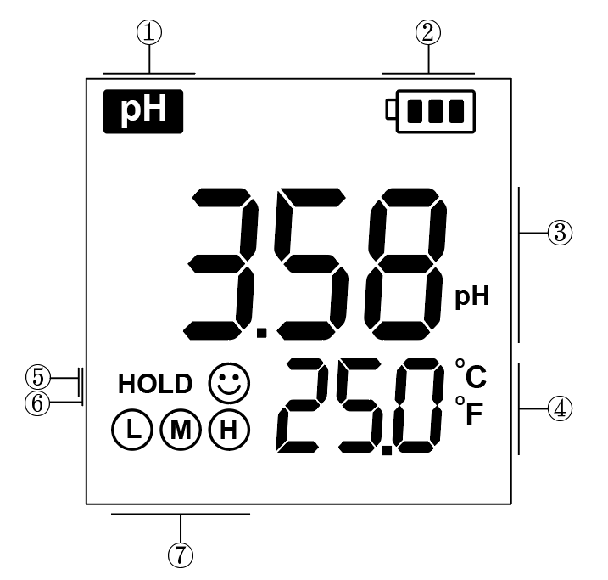3.1 Display screen（Blue color: measurement mode; Green color: calibration mode）

1. ------parameter test
2. ------battery power indication
3. ------Measurements
4. ------Temperature units
5. ------ HOLD Data freezing icon
6. ------reading stability icon
7. ------calibration points reminder

**3.2 Keypad functions**

|  |  |
| --- | --- |
|  | 1. Short press to power on. Long press to power off. 2. When powered off, long press to enter parameter setting mode. 3. In the measurement mode, short press to turn backlight on/off. 4. In the parameter setting mode, short press to exit and enter to measurement mode. |
|  | 1. In the measurement, short press to toggle between available measurement types：**pH → mV → mV (ORP)** 2. In the parameter setting up mode, short press to move among the parameter |
|  | 1. When powered on, long press to enter calibration mode 2. In the setting up mode, short press to confirm selection. 3. In the measurement mode, short press to hold or release the measured reading. |

**3.3 Electrode locking ring**

|  |  |
| --- | --- |
|  | Twist the electrode ring counter clockwise, pull out the old probe from the tester. |
|  | Align the groove of the new electrode module to the tongue on the tester, gently push the electrode into the slots to twist it in position.  Wear the new electrode ring and twist on tightly. |

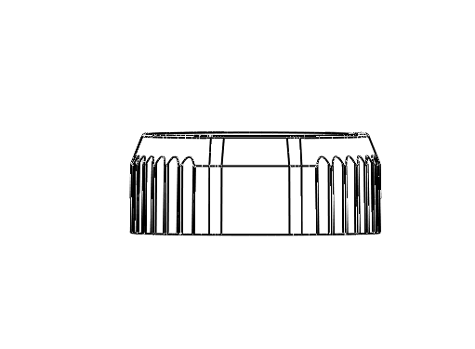

**3.4 Sensor types to different modes**

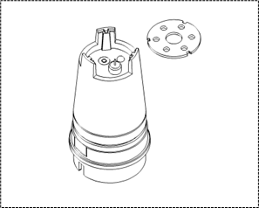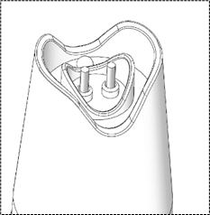

PH ORP COND PH/COND

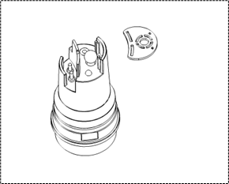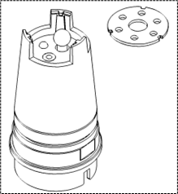

# Before use

* Check out the Items in package, including the electrode, shelf time of standard solution.
* Before measurement, it is necessary to confirm the meters had been set rightly as required, as: the data locking/backlight display/resolution/standard of calibration.

# Installing the batteries

Step: 02

Step: 01

Step: 04

Step: 03

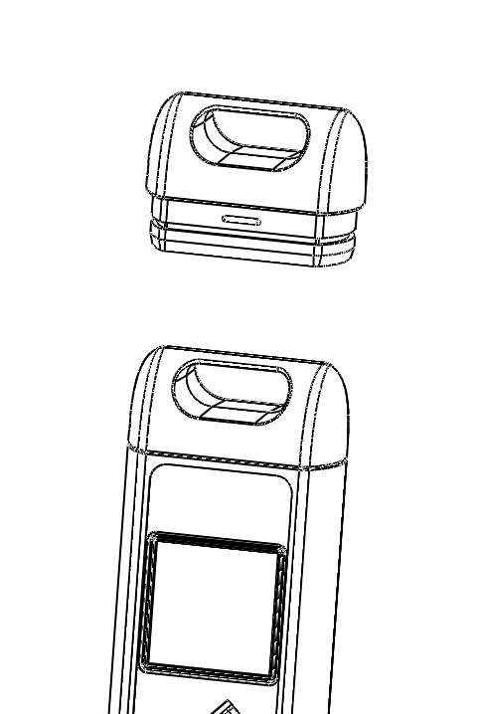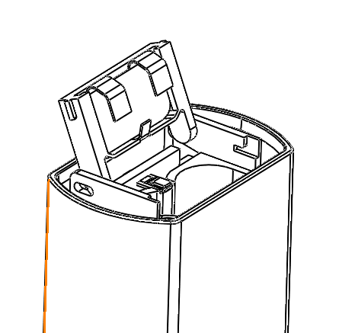

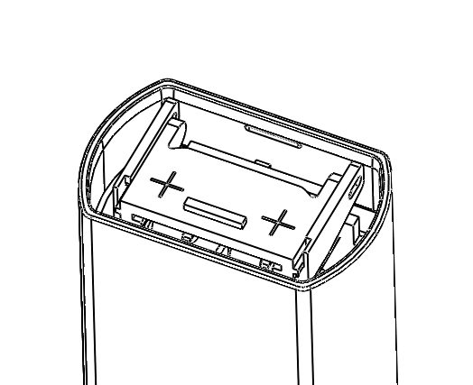

1. The front view
2. Pull the lid upwards
3. Push the plastic cover forwards and release
4. Remove the old batteries
5. Install new batteries (**all the positive polarity + must face up**)
6. Push the plastic cover forwards.
7. Close the lid tightly

**Note：**

* Never mixing use old and new batteries.
* Wrong installation direction of the batteries would lead to the battery electrolyte leakage and destroy the tester.

Step: 05

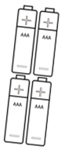

Step: 06



# Setup programs

|  |  |  |  |
| --- | --- | --- | --- |
| **Icons** | **Setup** | **Des.** | **Factory default setting** |
| **P01** | Temperature unit | ℃/℉ | ℃ |
| **P02** | Auto lock | 5-20 seconds - OFF | OFF |
| **P03** | Auto backlight | 1-8 minutes - OFF | 1 |
| **P04** | Auto shutoff | 10~20 minutes - OFF | 10 |
| **P05** | pH buffer solution series | CH - USA - NIST(PH) | USA |
| **P06** | pH resolution | 1-0.1-0.01 | 0.01 |
| **P07** | pH calibration reminder | H hours - D days - OFF  (set up in smart APP) | - |
| **P08** | Reset pH to factory default | No - Yes | No |
| **P09** | Conductivity Reference  Temperature | 15 ~ 30℃ | 25℃ |
| **P10** | Temp. Compensation Coefficient | 0 ~ 9.99% | 2.00% |
| **P11** | Auto Temperature compensation | 0~99℃ | 25℃ |
| **P12** | Cond solution series | CH - USA(COND) | USA |
| **P13** | Cond cell constant | 0.80~1.20 | 1.00 |
| **P14** | Cond calibration reminder | H hours - D days - OFF  (set up in smart APP) | - |
| **P15** | Reset Cond to factory default | No - Yes | No |
| **P16** | TDS factor | 0.40 ~ 1.00 | 0.71 |
| **P17** | Salinity unit | ppt - mg/L | ppt |
| **P18** | Display screen diagnostic | No/YES （LCD全亮5秒） | No |

**Ways to set parameters:**

* When turned off, long press key to enter parameter setting
* Short press to toggle among P01/P02/P03…
* Short press key, the parameter to select flickering
* Short presskey, move to the parameter
* Short presskey to confirm
* Short presskey to set the other parameter
* Short presskey to return to measurement mode

**Main parameter description：**

* Temp. unit (P01): ℃/℉
* Data hold (P02): set the reading hold from 5 to 20 seconds when the measurement stabilized between 5-20 seconds. For example, if set to 10 seconds, the meter will hold automatically after 10 seconds, and the HOLD icon will appear. To stop the HOLD, you can press the key to release/hold the reading manually.

1. Backlight color (P03)：Light the backlit color from 1 to 8 minutes; Off: turn off the backlight; In the measurement mode, short press key to turn on/off backlight manually.
2. Auto power off (P04): turn off the meter in 10 to 20 minutes if no operation. “OFF” turn off this function. In the measurement mode, long press to turn off the meter manually.
3. pH buffer standard (P05): USA/NIST/CH.
4. Calibration reminder (P07): available with the Bluetooth pocket testers.
5. Reset pH settings to factory default (P08): Yes: restore the meter to theoretical value (pH7.00 at 0mV with 100% slope).
6. Conductivity reference temperature (P09): set the reference temperature manually.
7. Temp. Compensation Coefficient (P10): the default setting 2.00%.
8. Auto Temperature compensation (P11): set the temperature compensation manually.
9. Factory default (P08&P15): This function can be used when instrument does not work well in calibration or measurement. Calibrate and measure again after setting the instrument back to factory default.

# pH module

## 7.1 pH calibration

1. Short press to turn on the tester, gently rinse the electrode in pure water, shaking dry, (For the first-time use or long time not in use, soak the electrode in pH/ORP electrode for 10-15 minutes).
2. Pour certain pH7.00 buffer solution in the sample vial, (around the Level of MAX line, 10ml).
3. Long press to enter calibration mode, backlight turns green, the pH7.00 appears on the bottom right，(short press to exit, if there`s no calibration needs).
4. Submerge the electrode in pH7.00, shake the electrode for a few seconds, then let it stand still, get the readings when the smile icon stands on the screen, short press to confirm the 1st point calibration, the tester returns to measurement mode, and shows up on the screen, indicating the first point is calibrated successfully.
5. Conduct the 2nd and 3rd pts calibration with pH4.00/10.01 buffer solution immediately if multi-pts calibration needed, and all the calibrated points icon will show up on the bottom left of the screen. (Do not turn off the tester during multi-pts calibration. Every calibration starts with the middle point pH7.00)



## 7.2 pH measurement

* Short press to power on, rinse the electrode in pure water and shake dry.
* Submerge the electrode in sample solution, stir gently, let it still, get the readings when the smile icon stays on screen. If the auto-hold function was preset, the readings will be hold automatically, you can short press to release the readings.

## 7.3 pH measurement notes

* + 1. For the most accurate pH measurements, the temperature of the sample solution and the calibration solution should be as the close.



* + 1. The tester is calibrated at the factory (calibrated icon stays on the screen). It can automatically recognize the buffer solutions as shown below. You can conduct 1 to 3pts calibration. The 1st point calibration must be pH7.00. To improve the accuracy, the 2nd pH buffer solution should cover the sample solution pH value. For example, if the pH value of the sample solution is around pH5.16, using a pH4.00 buffer solution would be best.

**DO NOT** turn off the tester during multi-pts calibration. If there`s a sudden shut off, please start the calibration with pH7.00 first (otherwise, the Er1 will appears).

|  |  |  |  |  |  |
| --- | --- | --- | --- | --- | --- |
| Cal points | **USA** | **NIST** | **CH** | **Calibration Icon** | **Recommended** |
| **1 point** | 7.00pH | 6.86pH | 6.86 pH | 符号-16符号-17 | ≤ ±0.1pH |
| **2 points** | 7.00pH/4.00pH | 6.86pH/4.01pH | 6.86pH/4.00pH | 符号-17 | <7.00 pH |
| 7.00pH/10.01pH | 6.86pH/9.18pH | 6.86pH/9.18pH | 符号-18符号-17 | >7.00 pH |
| **3 points** | 7.00pH/4.00pH/ 10.01pH | 6.86pH/4.01pH/9.18pH | 6.86pH/4.00pH/9.18pH |  | 0~14.00pH |

* + 1. Do not pour the solution back after use to avoid contamination.
    2. Strong acid, strong alkali, and organic solutions will accelerate the aging of the electrode bulb and the plastic shell solvent. Please avoid testing such substances.

# ORP module

## 8.1 ORP Measurement

* + - Short press key to turn the meter on. Press key to enter the mV (ORP) mode, as the right figure.
    - Connect the ORP probe to the tester（the ORP probe DORP1-S is optional）, rinse the front tip in the purified water, and shake-dry, gently stir it in the sample solution and let it still, get the readings when the smile icon stabilized.

**Note:** The Temp is on the screen, but this does not mean the temperature compensation is on the process.

## 8.2 ORP Measurement notes

* + In mV (ORP) measurement, there is no need of temperature compensation. ( the key will not activated in the mV (ORP) mode.），If there`s doubt about the quality of the ORP electrode or the test results, you can use the ORP standard solution to test its mV value to determine whether the ORP electrode or instrument is accurate or not.
  + The surface of the ORP measurement electrode (platinum or gold) should be bright. When the electrode used over a long period, the platinum surface will get polluted, which causes inaccurate measurement and slow response. In this case, please refer the following methods for cleaning and activation:

1. For inorganic pollution, the electrode can be immersed in 0.1mol/L dilute hydrochloric acid for 30 minutes, washed with pure water, and then immersed in the electrode soaking solution for 6 hours before use.
2. For organic oil and oil film contamination, clean the platinum surface with detergent, then rinse the electrode in pure water. After that, submerge the electrode in electrode soaking solution for 6 hours before use.
3. For heavily polluted platinum surface on which there is oxidation film, polish the platinum surface with toothpaste, then wash it in distilled water, then submerge it in the 3M soaking solution for 6 hours.

# Conductivity module

## 9.1. Conductivity calibration

* Short press to power on, short press to switch to Cond mode.
* Long press to enter calibration mode, the color of screen turns to green.
* Rinse the electrode in pure water, shake-dry, submerge the electrode in calibration solution 1413μs/cm, shake the electrode for a few seconds, then let it stand still.
* Get the readings when the smile icon stays on the screen, short press to confirm the calibration, the tester returns to measurement mode, and shows up on the screen, indicating the one point is calibrated successfully.

## 9.2. Conductivity measurement

* Submerge the electrode in sample solution, stir gently, let it still, get the conductivity readings when the smile icon stays on screen. If the auto-hold function was preset, the readings will be hold automatically, you can short press to release the readings.
* Short press key, switch among Cond/Res/TDS/SAL.

## 9.3. Conductivity measurement notes

1. Check whether the platinum rod is well. Any damage or surroundings on the electrode will cause measurement failure.
2. The tester is calibrated at the factory. You can perform the measurement directly. If there`s big error, please recalibrated the tester as required.
3. The RES/TDS/SAL parameter was converted from conductivity automatically.
4. You can select USA/CN standard series solution as below:

USA— 84μS/cm, 1413μS/cm, 12.88 mS/cm

CH — 146.6μS/cm, 1408μS/cm, 12.85mS/cm

1. The conductivity electrode is coated with a fluffy platinum black layer, to minimize the polarization effect and enlarge the measurement range. Therefore, Do Not wipe the platinum rod, you can rinse it in water or use warm detergent to clean the organic contamination, or use alcohol to clean it.
2. The default setting of the temp. compensation factor is 2.0%/˚C. User can adjust the factor based on sample solution and experimental data in parameter setting P10. The following table is some examples for setting up the temp. compensation factor.

|  |  |
| --- | --- |
| **Solution** | **Temperature compensation coefficient** |
| NaCl | 2.12%/℃ |
| 5%NaOH | 1.72%/℃ |
| Dilute ammonia | 1.88%/℃ |
| 10% Hydrochloric acid | 1.32%/℃ |
| 5% Sulfuric acid | 0.96%/℃ |

**Note:**

**When the coefficient for the temperature compensation is set to 0.00 (no compensation), the measurement value will be based on the current temperature.**

# Probe replacement

* Twist the electrode ring counter clockwise, pull out the old probe from the tester.
* Align the groove of the new electrode module to the tongue on the tester, gently push the electrode into the slots to twist it in position.
* Wear the new electrode ring and twist on tightly.

# Warranty

**The warranty covers (from delivery)：**

We warrant the tester against defects in material and workmanship when used in a normal manner for a period of two (2) years (12 months to the electrode).

Note: The electrodes are consumables, and the service life depends on careful maintenance, usage conditions, frequency of use, etc. Within 12 months from delivery, if the user finds that the electrode cannot be used due to processing and manufacturing problems when unpacking it for use, it can be repaired or replaced free of charge.

**The limited warranty does not cover the following:**

* Wear and tear to parts.
* Accidental damage, as the pH bulb broken from shocking.
* Misuse, uncarefully handling.
* Unauthorized maintenance, soldering, counterfeiting and others.

# Appendix：Troubleshooting

|  |  |  |
| --- | --- | --- |
| **Error** | **Reason** | **How to solve problem** |
| Can`t power on | No battery power | * Replace 4pcs new AAA alkaline battery, don`t mix the used one. * All the positive polarity of the batteries must face up. * Weak connection between battery lip and the batteries. Widen the spring tongue on the battery lid. |
| Inactive power key | Contact the supplier |
| Incorrect Temp. readings | The Temp. thermistor failure | Replace electrode |
| Strokes missing | LCD screen defective | Contact the supplier |
| The reading is nearly stable in all kinds of solutions | Short circuit | * Step 1: Replace electrode * If still in failure with Step 1, contact the supplier for meter maintenance |
| Calibration failure | * Electrode ageing * Air bubbles surrounding the electrode shield * Incorrect/Expired calibration solution * The electrode was not activated | * Replace electrode * Stir in the solution to remove the air bubble * Always Cal with pH7.00 and fresh solutions. * Soak in the pH/ORP electrode soaking solution for 24 hours |
| Reading keeps jumping/  Response slow/  Readings won`t stabilize | * There`s impurities surrounding the bulb/ junction * pH electrode ageing * There`s air bubble in the electrode | * Rinse clean * Replace electrode * Shake the electrode, to remove the air in the electrode |
| Er1 | Incorrect calibration solution | Press to cancel Er1, calibrate pH7.00 first |
| no response when long press | For ORP mode, calibration is not required. | Switch to pH mode, recalibrate the tester as required. |

**Note：**

Never rub the electrode tip with a cloth or hand, this will introduce an undesirable static electricity into the glass shaft of the electrode and prolong the response time considerably.

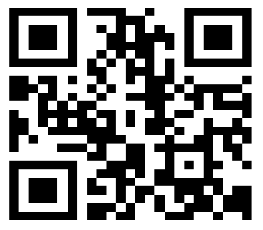

**Drawell International Technology Limited**

**Shanghai Drawell Scientific Instrument Co.,Ltd.**

**Chongqing Drawell Instrument Co.,Ltd.**

Add:Suite 2705,Building No.12,Shiyou Road No.1,Yuzhong District, Chongqing,China

Tel: 0086-023-63268643

Web : [www.drawell.com.cn](http://www.drawell.com.cn)

Email : [sales05@drawell.com.cn](mailto:sales05@drawell.com.cn)