Bluetooth Series Pocket Testers
User Manual



Please read operating manual before installation and operation.

Drawell International Technology Limited
Chongqing Drawell Instrument Co., Ltd.
Shanghai Drawell Scientific Instrument Co.,Ltd.

Address : Suite 2705,Building No.12,Shiyou Road No.1, Yuzhong District,
Chongqing China.
Homepage : www.drawell.com.cn
Tel : 0086-023-63268643
Email : sales05@drawell.com.cn

- PH+ Bluetooth Pocket pH/mV Tester
- ORP+ Bluetooth Pocket ORP Tester
- COND+ Bluetooth Pocket Conductivity Tester
- PH/COND+ Bluetooth Pocket pH/Conductivity Tester
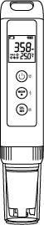

INDEX
1. Overview 3
1.1 Package Content 3
1.2 Key Features 3
2. Technical Specifications 4
3. Descriptions 6
4. Before use 7
5. Installing the Batteries 7
6. Setup Programs 8
7. pH Module 9
7.1 pH Calibration 9
7.2 pH Measurement 9
7.3 pH Measurement Notes 10
8. ORP Test 11
8.1 ORP Measurement 11
8.2 ORP Measurement notes 11
9. Conductivity Module 12
9.1. Conductivity calibration 12
9.2. Conductivity measurement 12
9.3. Conductivity measurement notes 12
10. Bluetooth connection 13
10.1 Bluetooth connection 13
10.2 The APP operation 13
11. Probe Replacement 14
12. Warranty 14
Appendix：Troubleshooting 15
NOTES
- There is a small amount of deionized water in the electrode storage cap to keep the electrode sensitiveness, which is normal.
- The probe is designed with a polycarbonate plastic (PC) shell. PC plastic will dissolve in certain organic solvents, such as carbon tetrachloride, trichlorethylene, tetrahydrofuran, toluene, xylene and methylethyl ketone, etc. Should avoid test samples solution containing such solvents.

Overview
Thank you for purchasing microprocessor-based waterproof pH/ EC / TDS / SALT Bluetooth tester with multi-color backlight display.
Be sure to read this manual before using the product to ensure proper and safe operation of the product. Also, safely store the manual so it is readily available whenever necessary. Product specifications and appearance as well as the contents of this manual are subject to change without notice.

1.1 Package Content
Model No. |  |  | PH+ | ORP+ | COND+ | PH/COND+
Test kit | 1 | Meter with pre-installed electrode | ✓ | ✓ | ✓ | ✓
Test kit | 2 | pH Buffer solution: 30mL pH4.00/7.00/10.01, one for each | ✓ | - | - | -
Test kit | 3 | 3mol KCl pH/ORP electrode soaking solution：10mL 1btl | ✓ | ✓ | - | ✓
Test kit | 4 | Sample vials: 30mL | 3pcs | 1pc | 2pcs | 4pcs
Test kit | 5 | ORP Standard solution：30mL 222mV, 1btl |  | ✓ | - | -
Test kit | 6 | Standard Cond solution: 30mL 1413μS/12.88mS/cm, one for each | - | - | ✓ | ✓
Test kit | 7 | pH buffer solution: 30mL pH4.00/7.00, one for each | - | - | - | ✓
Test kit | 8 | AAA alkaline battery: 4pcs (pre-installed) | ✓ | ✓ | ✓ | ✓
Test kit | 9 | Lanyard | ✓ | ✓ | ✓ | ✓
Test kit | 10 | Carrying case（spec：28.0×23.0×8.2cm） | ✓ | ✓ | ✓ | ✓

1.2 Key Features
- Multi-color backlit LCD display (blue with measurement, green with calibration, red with alarm), built-in microprocessor chip and automatic calibration. The instrument circuit board adopts SMT patch technology to improve the reliability.

- Adopts digital filtering and slip technology to intelligently improve the response speed of the instrument and the accuracy of measurement data. When the measurement is stable, the smile icon appears, and you can lock the reading manually or automatically.
- The electrode has a built-in temperature element, automatic temperature compensation, and automatic recognize the standard solutions among USA/NIST/CN. Calibration points: 1 to 3 pts automatic.
- The operation can be conducted via tester or mobile, multi APP display modes including, general mode, dial mode, diagram mode, and table mode.
- Waterproof and dustproof rating: IP67

Technical Specifications
pH
Measurement Range | （-2.00-16.00）pH
Resolution | 0.1/0.01 pH
Accuracy | ±0.01pH ± one digit
ATC range | （0-50）℃/（32-122）℉ automatically
Calibration | 1-3 points automatically
mV（ORP）
Measurement Range | -1000 mV - +1000 mV
Resolution | 0.1/1mV
Accuracy | ±0.1% F.S ± one digit
Temperature
Measurement Range | (0.0-60.0) ℃/ (32.0-140.0) °F
Resolution | ±0.2℃
Accuracy | 0.1
Conductivity
Measurement Range | （0～19.99）mS/cm
Resolution | 1/0.1/0.01
Calibration points | One point automatically
Accuracy | ±1.0% ±one digit
ATC Range | (0.0-60.0) ℃/ (32.0-140.0) °F automatically

Descriptions
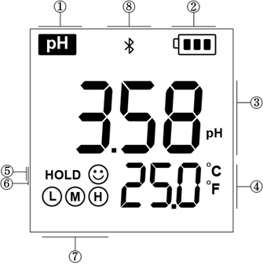
3.1 Display screen（Blue color: measurement mode; Green color: calibration mode）
- ------parameter test
- ------battery power indication
- ------Measurements
- ------temperature units
- ------ HOLD Data freezing icon
- ------reading stability icon
- ------calibration points reminder
- ------ Bluetooth connected

3.2 Keypad Functions
 | - Short press to power on. Long press to power off.  - When powered off, long press to enter parameter setting mode.  - In the measurement mode, short press to turn backlight on/off.  - In the parameter setting mode, short press to exit and enter to measurement mode.
- In the measurement, short press to toggle between available measurement types：pH → mV → mV (ORP)
- In the parameter setting up mode, short press to move among the parameter
 | - When powered on, long press to enter calibration mode  - In the setting up mode, short press to confirm selection.  - In the measurement mode, short press to hold or release the measured reading.

3.3 Electrode locking ring
Twist the electrode ring counter clockwise, pull out the old probe from the tester.
Align the groove of the new electrode module to the tongue on the tester, gently push the electrode into the slots to twist it in position.
Wear the new electrode ring and twist on tightly.
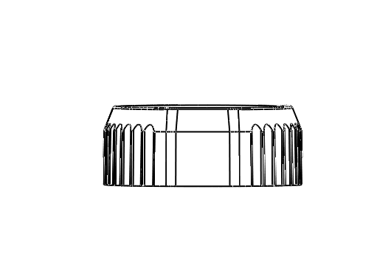

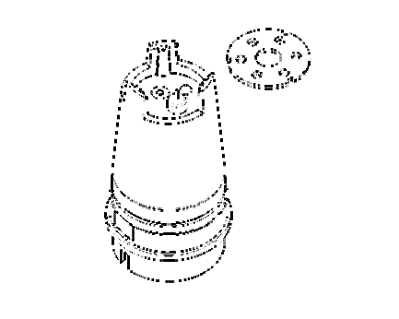
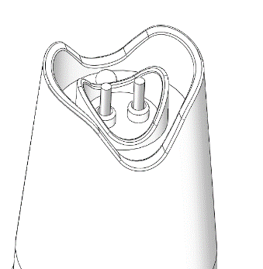
3.4 Sensor types to different modes
PH+ ORP+ COND+ PH/COND+

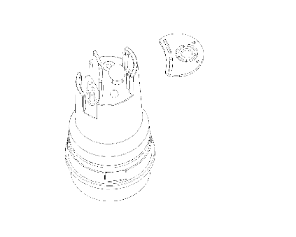
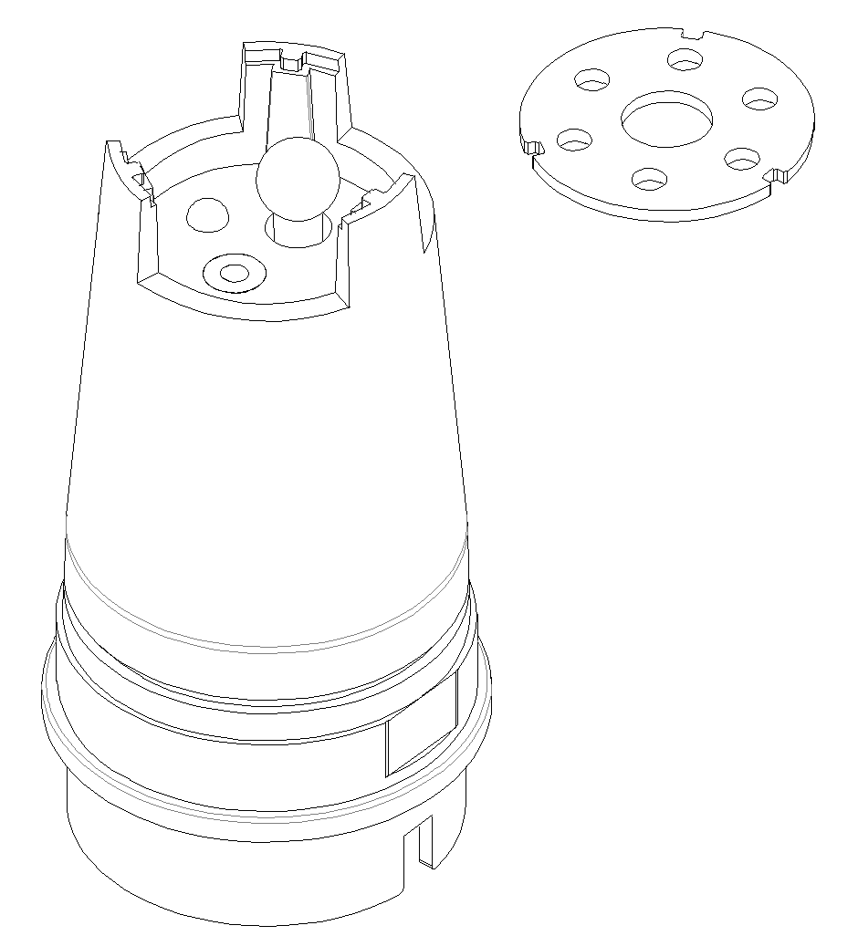

Before use
- Check out the Items in package, including the electrode, shelf time of standard solution.
- Before measurement, it is necessary to confirm the meters had been set rightly as required, as: the data locking/backlight display/resolution/standard of calibration.

Installing the Batteries
Step: 02
Step: 01
Step: 04
Step: 03
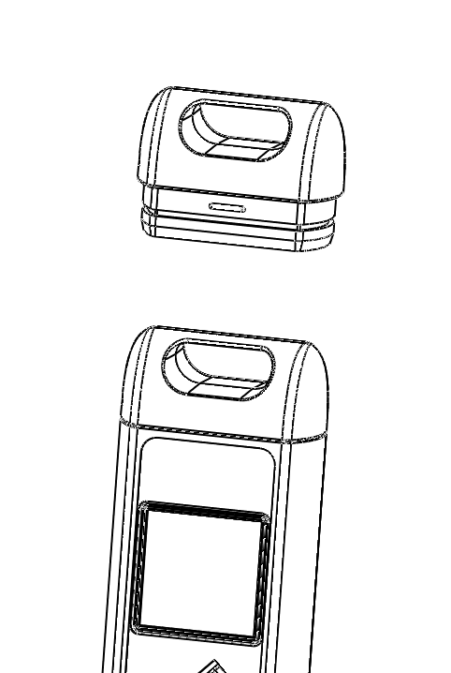
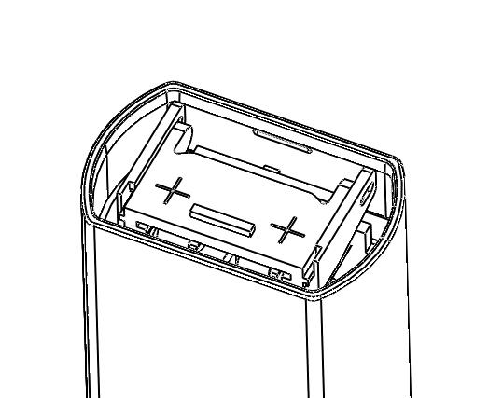
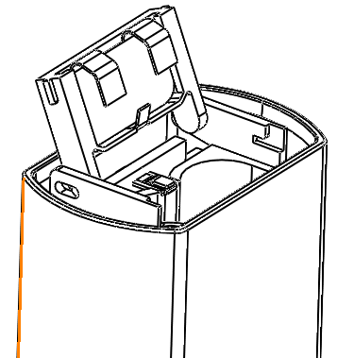

- The front view
- Pull the lid upwards
- Push the plastic cover forwards and release
- Remove the old batteries
- Install new batteries (all the positive polarity + must face up)
- Push the plastic cover forwards.
- Close the lid tightly
Note：
- Never mixing use old and new batteries.
- Wrong installation direction of the batteries would lead to the battery electrolyte leakage and destroy the tester.

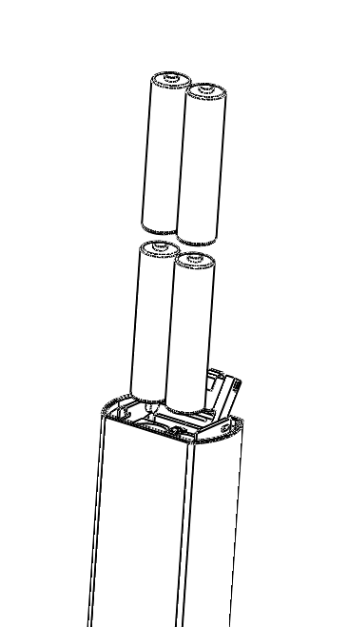
Step: 05
++
++

Step: 06

Setup Programs
Icons | Setup | Des. | Factory default setting
P01 | Temperature unit | ℃/℉ | ℃
P02 | Auto lock | 5-20 seconds - OFF | OFF
P03 | Auto backlight | 1-8 minutes - OFF | 1
P04 | Auto shutoff | 10~20 minutes - OFF | 10
P05 | pH buffer solution series | CH - USA - NIST(PH) | USA
P06 | pH resolution | 1-0.1-0.01 | 0.01
P07 | pH calibration reminder | H hours - D days - OFF  (set up in smart APP) | -
P08 | Reset pH to factory default | No - Yes | No
P09 | Conductivity Reference  Temperature | 15 ~ 30℃ | 25℃
P10 | Temp. Compensation Coefficient | 0 ~ 9.99% | 2.00%
P11 | Auto Temperature compensation | 0~99℃ | 25℃
P12 | Cond solution series | CH - USA(COND) | USA
P13 | Cond cell constant | 0.80~1.20 | 1.00
P14 | Cond calibration reminder | H hours - D days - OFF  (set up in smart APP) | -
P15 | Reset Cond to factory default | No - Yes | No
P16 | TDS factor | 0.40 ~ 1.00 | 0.71
P17 | Salinity unit | ppt - mg/L | ppt
P18 | Display screen diagnostic | No/YES （LCD全亮5秒） | No
Ways to set parameters:
- When turned off, long press key to enter parameter setting
- Short press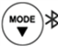 to toggle among P01/P02/P03…
- Short press key, the parameter to select flickering
- Short presskey, move to the parameter
- Short presskey to confirm
- Short presskey to set the other parameter
- Short presskey to return to measurement mode
Main parameter description：
- Temp. unit (P01): ℃/℉
- Data hold (P02): set the reading hold from 5 to 20 seconds when the measurement stabilized between 5-20 seconds. For example, if set to 10 seconds, the meter will hold automatically after 10 seconds, and the HOLD icon will appear. To stop the HOLD, you can press the key to release/hold the reading manually.
- Backlight color (P03)：Light the backlit color from 1 to 8 minutes; Off: turn off the backlight; In the measurement mode, short press key to turn on/off backlight manually.
- Auto power off (P04): turn off the meter in 10 to 20 minutes if no operation. “OFF” turn off this function. In the measurement mode, long press to turn off the meter manually.
- pH buffer standard (P05): USA/NIST/CH.
- Calibration reminder (P07): available with the Bluetooth pocket testers.
- Reset pH settings to factory default (P08): Yes: restore the meter to theoretical value (pH7.00 at 0mV with 100% slope).
- Conductivity reference temperature (P09): set the reference temperature manually.
- Temp. Compensation Coefficient (P10): the default setting 2.00%.
- Auto Temperature compensation (P11): set the temperature compensation manually.
- Factory default (P08&P15): This function can be used when instrument does not work well in calibration or measurement. Calibrate and measure again after setting the instrument back to factory default.

pH Module

7.1 pH Calibration
- Short press to turn on the tester, gently rinse the electrode in pure water, shaking dry, (For the first-time use or long time not in use, soak the electrode in pH/ORP electrode for 10-15 minutes).
- Pour certain pH7.00 buffer solution in the sample vial, (around the Level of MAX line, 10ml).
- Long press to enter calibration mode, backlight turns green, the pH7.00 appears on the bottom right，(short press to exit, if there`s no calibration needs).

- Submerge the electrode in pH7.00, shake the electrode for a few seconds, then let it stand still, get the readings when the smile icon stands on the screen, short press to confirm the 1st point calibration, the tester returns to measurement mode, and shows up on the screen, indicating the first point is calibrated successfully.


- Conduct the 2nd and 3rd pts calibration with pH4.00/10.01 buffer solution immediately if multi-pts calibration needed, and all the calibrated points icon will show up on the bottom left of the screen. (Do not turn off the tester during multi-pts calibration. Every calibration starts with the middle point pH7.00)

7.2 pH Measurement
- Short press to power on, rinse the electrode in pure water and shake dry.
- Submerge the electrode in sample solution, stir gently, let it still, get the readings when the smile icon stays on screen. If the auto-hold function was preset, the readings will be hold automatically, you can short press to release the readings.

7.3 pH Measurement Notes
    - For the most accurate pH measurements, the temperature of the sample solution and the calibration solution should be as the close.
    - The tester is calibrated at the factory (calibrated icon stays on the screen). It can automatically recognize the buffer solutions as shown below. You can conduct 1 to 3pts calibration. The 1st point calibration must be pH7.00. To improve the accuracy, the 2nd pH buffer solution should cover the sample solution pH value. For example, if the pH value of the sample solution is around pH5.16, using a pH4.00 buffer solution would be best.
DO NOT turn off the tester during multi-pts calibration. If there`s a sudden shut off, please start the calibration with pH7.00 first (otherwise, the Er1 will appears).
Cal points | USA | NIST | CH | Calibration Icon | Recommended
1 point | 7.00pH | 6.86pH | 6.86 pH |  | ≤ ±0.1pH
2 points | 7.00pH/4.00pH | 6.86pH/4.01pH | 6.86pH/4.00pH |  | <7.00 pH
2 points | 7.00pH/10.01pH | 6.86pH/9.18pH | 6.86pH/9.18pH |  | >7.00 pH
3 points | 7.00pH/4.00pH/ 10.01pH | 6.86pH/4.01pH/9.18pH | 6.86pH/4.00pH/9.18pH |  | 0~14.00pH
    - Do not pour the solution back after use to avoid contamination.
    - Strong acid, strong alkali, and organic solutions will accelerate the aging of the electrode bulb and the plastic shell solvent. Please avoid testing such substances.

ORP Test

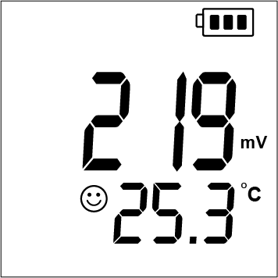
8.1 ORP Measurement
    - Short press key to turn the meter on. Press key to enter the mV (ORP) mode, as the right figure.
    - Connect the ORP probe to the tester（the ORP probe: DORP1-S is optional）, rinse the front tip in the purified water, and shake-dry, gently stir it in the sample solution and let it still, get the readings when the smile icon stabilized.
Note: The Temp is on the screen, but this does not mean the temperature compensation is on the process.

8.2 ORP Measurement notes
  - In mV (ORP) measurement, there is no need of temperature compensation. ( the key will not activated in the mV (ORP) mode.），If there`s doubt about the quality of the ORP electrode or the test results, you can use the ORP standard solution to test its mV value to determine whether the ORP electrode or instrument is accurate or not.
  - The surface of the ORP measurement electrode (platinum or gold) should be bright. When the electrode used over a long period, the platinum surface will get polluted, which causes inaccurate measurement and slow response. In this case, please refer the following methods for cleaning and activation:
- For inorganic pollution, the electrode can be immersed in 0.1mol/L dilute hydrochloric acid for 30 minutes, washed with pure water, and then immersed in the electrode soaking solution for 6 hours before use.
- For organic oil and oil film contamination, clean the platinum surface with detergent, then rinse the electrode in pure water. After that, submerge the electrode in electrode soaking solution for 6 hours before use.
- For heavily polluted platinum surface on which there is oxidation film, polish the platinum surface with toothpaste, then wash it in distilled water, then submerge it in the 3M soaking solution for 6 hours.

Conductivity Module

9.1. Conductivity calibration
- Short press to power on, short press to switch to Cond mode.
- Long press to enter calibration mode, the color of screen turns to green.

- Rinse the electrode in pure water, shake-dry, submerge the electrode in calibration solution 1413μs/cm, shake the electrode for a few seconds, then let it stand still.
- Get the readings when the smile icon stays on the screen, short press to confirm the calibration, the tester returns to measurement mode, and shows up on the screen, indicating the one point is calibrated successfully.

9.2. Conductivity measurement
- Submerge the electrode in sample solution, stir gently, let it still, get the conductivity readings when the smile icon stays on screen. If the auto-hold function was preset, the readings will be hold automatically, you can short press to release the readings.
- Short press key, switch among Cond/Res/TDS/SAL.

9.3. Conductivity measurement notes
- Check whether the platinum rod is well. Any damage or surroundings on the electrode will cause measurement failure.
- The tester is calibrated at the factory. You can perform the measurement directly. If there`s big error, please recalibrated the tester as required.
- The RES/TDS/SAL parameter was converted from conductivity automatically.
- You can select USA/CN standard series solution as below:
USA— 84μS/cm, 1413μS/cm, 12.88 mS/cm
CH — 146.6μS/cm, 1408μS/cm, 12.85mS/cm
- The conductivity electrode is coated with a fluffy platinum black layer, to minimize the polarization effect and enlarge the measurement range. Therefore, Do Not wipe the platinum rod, you can rinse it in water or use warm detergent to clean the organic contamination, or use alcohol to clean it.
- The default setting of the temp. compensation factor is 2.0%/˚C. User can adjust the factor based on sample solution and experimental data in parameter setting P10. The following table is some examples for setting up the temp. compensation factor.
Solution | Temperature compensation coefficient
NaCl | 2.12%/℃
5%NaOH | 1.72%/℃
Dilute ammonia | 1.88%/℃
10% Hydrochloric acid | 1.32%/℃
5% Sulfuric acid | 0.96%/℃
Note:
When the coefficient for the temperature compensation is set to 0.00 (no compensation), the measurement value will be based on the current temperature.

Bluetooth connection
With a Bluetooth chip built-in, users can conduct the test via the meter or the mobile phone.

10.1 Bluetooth connection


- Pocket Tester: short press to power on, long press to activate the Bluetooth communication.
- Smart mobile phone: scan the QR code and install the “SMT” APP, allow the location access.
- Click the Bluetooth icon , select the tester “SMT” to start Bluetooth communication.
Bluetooth APP

10.2 The APP operation
- Click to enter the calibration mode.
- Click Settings to enter parameter settings (General information, standard solution series, measurement high and low value warnings, etc.).
- Click Save to manually store the measured values.
- Click Auto Save to start the timing storage.
- Click Hold to manually locked and the tester displays HOLD icon. Click Hold again to release the data.
Note: When the screen is red, it indicates that the measurement exceeds the warning value settings. Click the Settings to enter the alarm mode to close warning or modify the warning value to fix this issue.

Probe Replacement
- Twist the electrode ring counter clockwise, pull out the old probe from the tester.
- Align the groove of the new electrode module to the tongue on the tester, gently push the electrode into the slots to twist it in position.
- Wear the new electrode ring and twist on tightly.

Warranty
The warranty covers (from delivery)：
We warrant the tester against defects in material and workmanship when used in a normal manner for a period of two (2) years (12 months to the electrode).
Note: The electrodes are consumables, and the service life depends on careful maintenance, usage conditions, frequency of use, etc. Within 12 months from delivery, if the user finds that the electrode cannot be used due to processing and manufacturing problems when unpacking it for use, it can be repaired or replaced free of charge.
The limited warranty does not cover the following:
- Wear and tear to parts.
- Accidental damage, as the pH bulb broken from shocking.
- Misuse, uncarefully handling.
- Unauthorized maintenance, soldering, counterfeiting and others.

Appendix：Troubleshooting
Error | Reason | How to solve problem
Can`t power on | No battery power | - Replace 4pcs new AAA alkaline battery, don`t mix the used one.  - All the positive polarity of the batteries must face up.  - Weak connection between battery lip and the batteries. Widen the spring tongue on the battery lid.
Can`t power on | Inactive power key | Contact the supplier
Incorrect Temp. readings | The Temp. thermistor failure | Replace electrode
Strokes missing | LCD screen defective | Contact the supplier
The reading is nearly stable in all kinds of solutions | Short circuit | - Step 1: Replace electrode  - If still in failure with Step 1, contact the supplier for meter maintenance
Calibration failure | - Electrode ageing  - Air bubbles surrounding the electrode shield  - Incorrect/Expired calibration solution  - The electrode was not activated | - Replace electrode  - Stir in the solution to remove the air bubble  - Always Cal with pH7.00 and fresh solutions.  - Soak in the pH/ORP electrode soaking solution for 24 hours
Reading keeps jumping/  Response slow/  Readings won`t stabilize | - There`s impurities surrounding the bulb/ junction  - pH electrode ageing  - There`s air bubble in the electrode | - Rinse clean  - Replace electrode  - Shake the electrode, to remove the air in the electrode
Er1 | Incorrect calibration solution | Press to cancel Er1, calibrate pH7.00 first
no response when long press | For ORP mode, calibration is not required. | Switch to pH mode, recalibrate the tester as required.
   | Measurement exceeds the Warning settings | Cancel or modify the warning settings in the APP.

Note：
Never rub the electrode tip with a cloth or hand, this will introduce an undesirable static electricity into the glass shaft of the electrode and prolong the response time considerably.

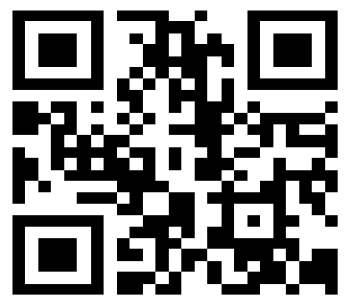

Drawell International Technology Limited

Shanghai Drawell Scientific Instrument Co.,Ltd.

Chongqing Drawell Instrument Co.,Ltd.

Add:Suite 2705,Building No.12,Shiyou Road No.1,Yuzhong District, Chongqing,China

Tel: 0086-023-63268643

Web : www.drawell.com.cn

Email : sales05@drawell.com.cn

