**DDOPRO10**

**Portable Dissolved Oxygen Meter**

**User Manual**



Please read operating manual before installation and operation.

**[Drawell International Technology Limited](http://www.drawell.com.cn/)**

**Chongqing Drawell Instrument Co., Ltd.**

**Shanghai Drawell Scientific Instrument Co.,Ltd.**

**Address** : Suite 2705,Building No.12,Shiyou Road No.1, Yuzhong District,

Chongqing China.

**Homepage** : [www.drawell.com.cn](http://www.drawell.com.cn/)

**Tel** : 0086-023-63268643

**Email** : [sales05@drawell.com.cn](mailto:sales01@drawell.com.cn)

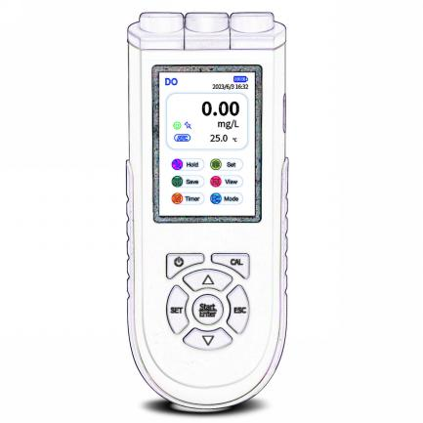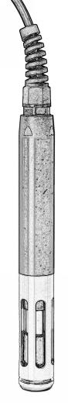

INDEX

1. Overview 3

1.1 Package Content 3

1.2 Key Features 3

2. Technical Specifications 4

3. Descriptions 4

3.1 Measurement screen 4

3.2 Meter socket 4

3.3 Operation keys 5

3.4 Screen Icons 5

4. Instrument checking 5

5. Optical DO probe 6

6. Sensor Caps 6

7. Sensor Storage 7

8. General parameter setting 8

9. DO Module 8

9.1 DO menu setting 8

9.2 DO Calibration 9

9.3 DO Measurement 9

9.4 Notes about the DO test 9

10. Data storage 10

11. PC communication 10

12. Warranty 12

13. Appendix A： Content of Saturated Oxygen in water at different temperatures 13

14. Appendix B：Content of Saturated Oxygen at different air pressure 14

15. Appendix C : Content of Saturated Oxygen at different altitude 15

16. Appendix D: Troubleshooting 16

**Notes**

* **NEVER test the solution with the temperature higher than 50℃.**
* **NEVER use alcohol or organic solvents to clean the probes, otherwise it may damage the probe.**
* **Before getting readings or performing other operations, wait about 30 seconds after meter is powered on.**

# Overview

Thank you for purchasing microprocessor-based optical DO meter. This instrument uses fluorescence technology to measure dissolved oxygen in water. The advantage of this optical sensor is that the stirring is unnecessary. Needless to warm up, compared with the traditional polarographic DO sensor measurements, providing better test stability and repeatability.

Be sure to read this manual before using the product to ensure proper and safe operation of the product. Also, safely store the manual so it is readily available whenever necessary.

Product specifications and appearance as well as the contents of this manual are subject to change without notice.

## Package Content

* 1. Meter: 1pc
  2. Optical DO probe ODO01-3M: 1pc
  3. H10-LI01 Rechargeable lithium battery(pre-installed): 1pc
  4. Charging cable: 1pc
  5. Carrying case 33×27.2×8.2cm: 1pc
  6. Operation manual: 1pc

## Key Features

* + 3.5″ TFT Color Display, easy to read.
  + Foldable meter stand.
  + Adopts digital filtering and slip technology to intelligently improve the response speed of the instrument and the accuracy of measurement data.
  + When the measurement is stable, the smile icon stays on the screen, and you can lock the reading manually or automatically.
  + Automatic temperature compensation, automatic barometric compensation.
  + Equipped with an optical DO probe, easy to use, hassle-free maintenance, needless to stir, and can get more reliable test.
  + The electrode designed with a robust POM shaft, and a durable protection guard, service-life extended.
  + Needless polarization, no frequently calibration required.
  + Lithium battery and Type C/USB powered.
  + Waterproof and dustproof rating: IP57.
  + Features of the PC software:
  + Sample ID identification
  + User level management
  + Operation history record
  + Data print/export
  + Timing data logger

# Technical Specifications

**2.1. Dissolved Oxygen**

| Measurement Range | (0.00-20.00）mg/L; (0-200.0) % |
| --- | --- |
| Resolution | 0.1/0.01 |
| Accuracy | ±0.20 mg/L |
| Response time | 30s≤ (25℃, 90% response) |
| Residual current | ≤0.1 mg/L |
| Temp. compensation range | (0-50) ℃ (automatic) |
| Air pressure compensation range | （0-200.0）kPa (automatic) |
| Salinity compensation range | （0-45）ppt (manual) |
| Auto calibration | Water saturated air/air saturated water |
| Electrode type | Polarographic type |

|  |  |
| --- | --- |
| Data storage | 3000 groups |
| Charging port | Type-C |
| Power supply | Rechargeable lithium battery, Type-C USB |
| IP rating | IP57 |

**2.2．Others**

# Descriptions

## 3.1 Measurement screen

* Long press to power on.
* Short press to move, when the ion highlighted, press to start the mode selection, press to confirm.
* When confirmed, the meter returns to measurement mode automatically.

the display screen

## 3.2 Meter socket

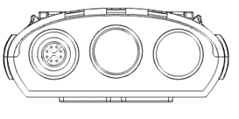

|  |
| --- |
| 8 pins-measure dissolved oxygen |

## 3.3 Operation keys

|  |  |
| --- | --- |
|  | Long press to power on/off |
|  | Shortcut key to enter Cal mode |
|  | * Parameter setting confirmation * Calibration confirmation |
|  | * Exit Cal mode * Exit parameter setting |
|  | * Press to enter parameter setting * In the measurement mode, long press to change the pH resolution: 0.1/0.01/0.001 |
|  | Parameter or data scroll up selection |
|  | Parameter or data scroll down selection |

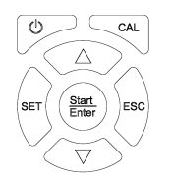

## 3.4 Screen Icons

Press to move, when the icon below highlighted, press to start settings

|  |  |
| --- | --- |
|  | Hold/release data manually |
|  | Enter parameter setting (see flow chart below)  In the data review mode, long press to delete all the saved data. |
|  | Save the readings manually (number, parameter, data, temperature, data) |
|  | In the measurement mode, press to check data saved. (press to scroll screen) |
|  | Timing data storage (0.5m, 1m, 2m, 3m, 5m, 10m, 20m, and 30m; OFF) |
|  | Choose the parameter: pH→mV→ORP→COND(RES/TDS/SAL) →DO(SAT) |

# Instrument checking

* Check the package content with list.
* Check the appearance of the instrument. The electrode connector should be kept dry and clean. The electrode should not be damaged.
* Damages, scratches on the optical surface causes faulty measured values. Ensure that the optical surface is not scratched or damaged in any way.

# Optical DO probe

**Measuring principles:**

The optics in the sensor send green light pulses to the fluorescence layer.

The markers "answer" (fluoresce) with red light pulses.

The duration and intensity of the response signals is directly dependent on the oxygen contents

and the partial pressure.

If the medium is free from oxygen, the response signals are long and very intense.

Oxygen molecules quench the marker molecules. As a result, the response signals are shorter

and less intense.

**Measurement result:**

The sensor returns a signal that is in proportion to the oxygen concentration in the medium.

The medium temperature and air pressure are already taken into account calculated in the

Sensor.

# Sensor Caps

* Please don`t remove the sensor caps and exchange it with others.
* When not in use, should keep the sensor cap in a humidity environment. When in use, please keep place the cap well in case of lost. If the moisture sponge in the cap was dried out, add a few drops of water in it.
* When the coating layer is in dry, should let it stand in a warm tap water for 24 hours to regenerate it, then conduct calibration and measurement.
* The sensor cap has a service life of more than 8000 hours. When the probe is not being used, the service life will not be reduced, so the actual use time of the sensor cap is far more than a year. The major factor affecting the service life of the sensor cap is the surface coating being damaged under external force. So the key is to protect the sensor cap from external damage.
* If the surface of the sensor cap is contaminated, you can wipe it with a soft clean cloth gently. To disinfect the probe, immerse it in 3% hydrogen peroxide for 15 to 30 minutes and then rinse off with clean water. NEVER scratch the coating layer.
* The interior of the sensor cap should never be contaminated or wet. the sensor cap must be tightened, and the interior can`t be contaminated or wet.

# **Sensor Storage**

**SHORT TERM STORAGE** (less than 30 days)

The probe is supplied with a black protection cap that a moisture sponge put in, which is used for a short-term storage. Be sure to keep a small amount of moisture (tap water) on the sponge in the cap during storage. This is simply done to maintain a 100% water saturated air environment which is ideal for short-term sensor storage. The sensors should not be submersed in water, the intent is to create a humid air storage environment.

**LONG TERM STORAGE** (more than 30 days)

The probe head is kept in the calibration sleeve. Check whether the storage sponge is moist every 30 days or user can store the electrode in a beaker containing clean water.

The sponge can`t be allowed to get stained or moldy, otherwise it will consume or produce oxygen. If stained or moldy, please replace it immediately.

# **General parameter setting**

**Others**

**Date**

**Manual Temp compensation**

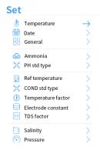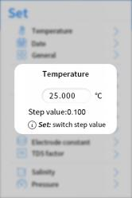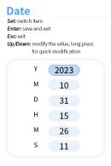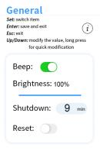

*Press* **SET** *to move the decimal point*



*Press* **SET** *to move.*

*Press to change the settings*





# DO Module

## 9.1 DO menu setting

* Long press to power on.
* Short press to move, when the icon highlighted, press to enter the Mode selection, as shown on the right.

**9.2 DO submenu setting**

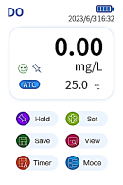Short press to move, when the icon highlighted, press to enter the Mode settings.

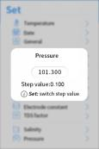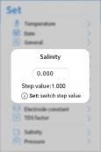

Manual salinity compensation

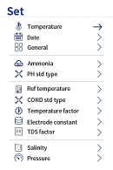

Automatic barometric compensation.

Press SET to move the decimal digit.

## **9.3 DO Calibration**

**DO Calibration**

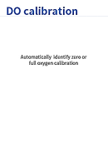

Diagram 13

**Full Saturated oxygen calibration:**

* Press to enter calibration mode, as show on the right.
* Place the electrode in air, wait for the green smile icon displays, press to confirm the calibration, and the “Full oxygen calibration completed” on the screen reminds of the calibration completed.
* Press to confirm and the meter turns to measurement mode.

**Zero oxygen calibration:**

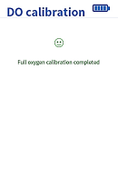Usually there is no need to do zero oxygen calibration unless you have a high requirement for accuracy in low oxygen level (<1.0ppm) or you are replacing the DO electrode, DO sensor cap, and long term not in use. To do zero oxygen calibration, follow the steps below:

* Prepare 100mL of zero-oxygen water: In a 100 mL beaker, add in 5.0g anhydrous sodium sulfite (Na2SO3) and distilled water to 100 mL, mix well to dissolve. Note that the zero-oxygen water is only effective within 24 hours.
* Power on the meter, and wait for about 30 seconds, then calibrate the meter.
* Submerge the DO in zero oxygen water, enter the calibration mode, wait for the green smile icon displays, press for calibration confirmation. The meter conducted the calibration in a few minutes.

## **9.4** DO Measurement

Suitable flow is not necessarily mandatory but it does improve the speed at which the measuring system responds and ensures a more representative measured value compared to a measurement in static medium

## **9.5 Notes about the DO test**

1. When calibration, the temperature difference between the sample solution and the air should be the close(≤10℃), If the temperature difference is too large, you can immerse the DO electrode in the sample water for about 10 minutes, and then perform the calibration immediately.
2. Temperature impacts the DO measurement significantly. When the electrode temperature and water temperature have larger difference, the reading time must be greater than 3 minutes. Otherwise, there could be some large errors.
3. The salinity and air pressure also affect DO measurement. The meter has automatic air pressure compensation and manual salinity compensation, you can input the value from the parameter setting as in Clause 9.2.
4. When the meter performs abnormal, you can restore the meter to factory default settings, and conduct the calibration before measurement.

# Data storage

**Manual data storage:**

In the measurement mode, press to move, when the icon highlighted, press to save data.

**Automatic data storage:**

 In the measurement mode, press to move, when the  icon highlighted, press to select the interval storage period. Press to confirm selection. The meter enters automatic interval data storage mode with a beep reminder for each storage. (OFF: cancel the automatic storage setting）

**Data erase**

This instrument can store up to 3000 groups of data. When the storage room is full, new data will automatically overwrite the recently stored value.

* In the measurement mode, press to move, when the  icon highlighted, press to enter the data review mode,
* Long press SET, **ALL** the data saved will be erased immediately.

# PC communication

* Long press to power on the meter
* When the PC software installed (contact supplier for the PC software), connect the data synchronized cable to the meter and USB port respectively.
* Click the icon to login, the default name “Admin” and password “admin”, the PC software displays a successfully connection as below, (also there`s a computer icon on the meter screen), click **Start** to use.

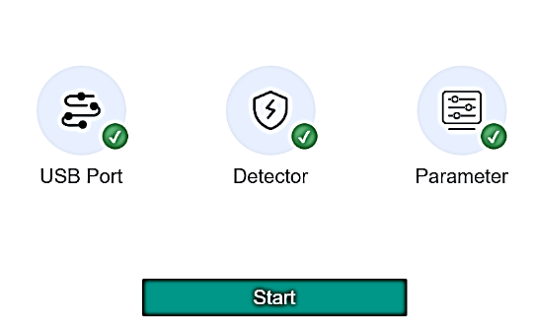

* The PC interface and sub-menu definition

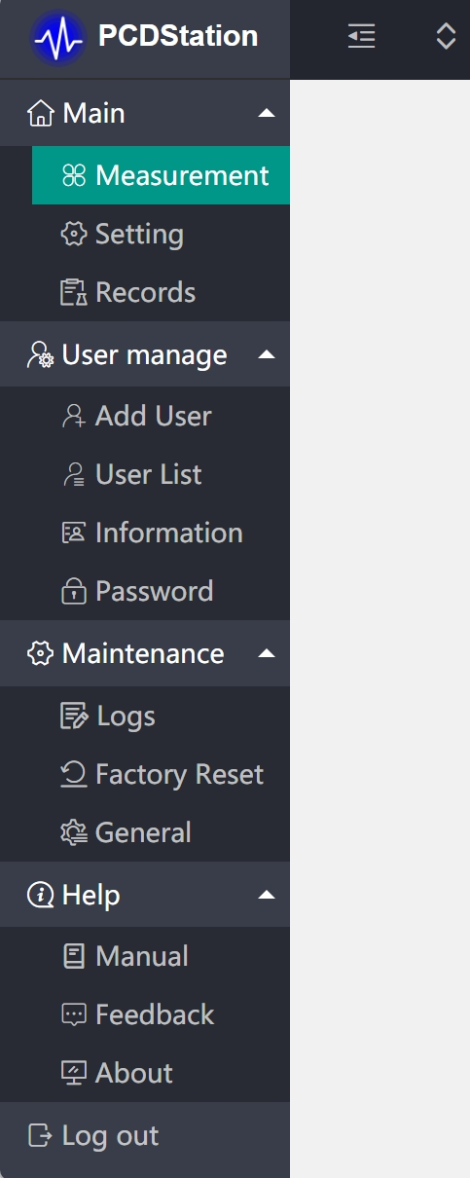

Parameter/Data hold/Interval storage/Sample ID

General parameter settings, meter operation lock

PC records view/print/export/delete

Instrument records export

**Main mode**

Add new User

Check the User List

**User Manage multi-level user management**

The user information view

Update password

Operation history record

Factory reset

The PC Operation beep settings. Instrument ID

**Help information**

Quick manual

Feedback

About us

**Maintenance**

# Warranty

**The warranty covers (from delivery)：**

We warrant the tester against defects in material and workmanship when used in a normal manner for a period of two (2) years (12 months to the electrode).

Note: The electrodes are consumables, and the service life depends on careful maintenance, usage conditions, frequency of use, etc. Within 12 months from delivery, if the user finds that the electrode cannot be used due to processing and manufacturing problems when unpacking it for use, it can be repaired or replaced free of charge.

**The limited warranty does not cover the following:**

* Wear and tear to parts.
* Accidental damage, as the pH bulb broken from shocking.
* Misuse, uncarefully handling.
* Unauthorized maintenance, soldering, counterfeiting and others.

# Appendix A： Content of Saturated Oxygen in water at different temperatures

|  |  |  |  |  |  |
| --- | --- | --- | --- | --- | --- |
| **Temp**  **℃** | **DO**  **mg/L** | **Temp**  **℃** | **DO**  **mg/L** | **Temp**  **℃** | **DO**  **mg/L** |
| **0** | 14.64 | 16 | 9.86 | 32 | 7.30 |
| **1** | 14.22 | 17 | 9.66 | 33 | 7.18 |
| **2** | 13.82 | 18 | 9.46 | 34 | 7.07 |
| **3** | 13.44 | 19 | 9.27 | 35 | 6.95 |
| **4** | 13.09 | 20 | 9.08 | 36 | 6.84 |
| **5** | 12.74 | 21 | 8.90 | 37 | 6.73 |
| **6** | 12.42 | 22 | 8.73 | 38 | 6.63 |
| **7** | 12.11 | 23 | 8.57 | 39 | 6.53 |
| **8** | 11.81 | 24 | 8.41 | 40 | 6.43 |
| **9** | 11.53 | 25 | 8.25 | 41 | 6.34 |
| **10** | 11.26 | 26 | 8.11 | 42 | 6.25 |
| **11** | 11.01 | 27 | 7.96 | 43 | 6.17 |
| **12** | 10.77 | 28 | 7.82 | 44 | 6.09 |
| **13** | 10.53 | 29 | 7.69 | 45 | 6.01 |
| **14** | 10.30 | 30 | 7.56 |  |  |
| **15** | 10.08 | 31 | 7.43 |  |  |

# Appendix B：Content of Saturated Oxygen at different air pressure

|  |  |  |  |  |
| --- | --- | --- | --- | --- |
| **Air pressure** | | **DO（mg/L）** | | |
| **MmHg** | kPa | 15℃ | 25℃ | 35℃ |
| **750** | 100.00 | 9.94 | 8.14 | 6.85 |
| **751** | 100.13 | 9.96 | 8.15 | 6.86 |
| **752** | 100.26 | 9.97 | 8.16 | 6.87 |
| **753** | 100.40 | 9.98 | 8.17 | 6.88 |
| **754** | 100.53 | 9.99 | 8.18 | 6.89 |
| **755** | 100.66 | 10.00 | 8.20 | 6.90 |
| **756** | 100.80 | 10.01 | 8.21 | 6.91 |
| **757** | 100.93 | 10.03 | 8.22 | 6.92 |
| **758** | 101.06 | 10.04 | 8.23 | 6.93 |
| **759** | 101.20 | 10.07 | 8.24 | 6.94 |
| **760** | 101.33 | 10.08 | 8.25 | 6.95 |
| **761** | 101.46 | 10.09 | 8.26 | 6.96 |
| **762** | 101.60 | 10.11 | 8.27 | 6.97 |
| **763** | 101.73 | 10.12 | 8.28 | 6.98 |
| **764** | 101.86 | 10.14 | 8.30 | 6.99 |
| **765** | 102.00 | 10.15 | 8.31 | 7.00 |
| **766** | 102.13 | 10.16 | 8.32 | 7.01 |
| **767** | 102.26 | 10.18 | 8.33 | 7.02 |
| **768** | 102.40 | 10.19 | 8.34 | 7.02 |
| **769** | 102.53 | 10.21 | 8.35 | 7.03 |
| **770** | 102.66 | 10.22 | 8.36 | 7.04 |
| **771** | 102.80 | 10.23 | 8.37 | 7.05 |
| **772** | 102.93 | 10.25 | 8.39 | 7.06 |
| **773** | 103.06 | 10.26 | 8.40 | 7.07 |
| **774** | 103.19 | 10.28 | 8.41 | 7.08 |
| **775** | 103.33 | 10.29 | 8.42 | 7.09 |

# Appendix C : Content of Saturated Oxygen at different altitude

|  |  |  |  |  |  |  |  |  |  |
| --- | --- | --- | --- | --- | --- | --- | --- | --- | --- |
| **Altitude** | | **Air pressure** | | **DO** | **Altitude** | | **Air pressure** | | **DO** |
| **foot** | meter | kPa | mmHg | mg/l | foot | meter | kPa | mmHg | mg/l |
| **0** | 0 | 101.3 | 760 | 8.25 | 7500 | 2287 | 77.1 | 579 | 6.28 |
| **500** | 152 | 9934 | 746 | 8.09 | 8000 | 2439 | 75.63 | 568 | 6.16 |
| **1000** | 305 | 97.6 | 733 | 7.95 | 8500 | 2591 | 74.44 | 559 | 6.06 |
| **1500** | 457 | 95.87 | 720 | 7.81 | 9000 | 2744 | 72.97 | 548 | 5.94 |
| **2000** | 610 | 94.28 | 708 | 7.68 | 9500 | 2896 | 71.64 | 538 | 5.83 |
| **2500** | 762 | 92.54 | 695 | 7.54 | 10000 | 3049 | 70.17 | 527 | 5.71 |
| **3000** | 915 | 90.95 | 683 | 7.41 | 10500 | 3201 | 68.84 | 517 | 5.61 |
| **3500** | 1067 | 89.35 | 671 | 7.28 | 11000 | 3354 | 67.38 | 506 | 5.49 |
| **4000** | 1220 | 87.75 | 659 | 7.15 | 12000 | 3659 | 66.58 | 500 | 5.42 |
| **4500** | 1372 | 86.15 | 647 | 7.02 | 13000 | 3963 | 65.78 | 494 | 5.36 |
| **5000** | 1524 | 84.56 | 635 | 6.89 | 14000 | 4268 | 64.98 | 488 | 5.29 |
| **5500** | 1677 | 83.09 | 624 | 6.77 | 15000 | 4573 | 64.18 | 482 | 5.23 |
| **6000** | 1829 | 81.63 | 613 | 6.65 | 16000 | 4878 | 63.38 | 476 | 5.16 |
| **6500** | 1982 | 80.03 | 601 | 6.52 | 17000 | 5183 | 62.58 | 470 | 5.10 |
| **7000** | 2134 | 78.56 | 590 | 6.40 | 18000 | 5488 | 61.79 | 464 | 5.03 |

Conversion of mmHg to kPa:

mmHg×0.13333=kPa

e.g. 200 mmHg = 200 × 0.133 = 26.6 kPa.

DOpt=P×DOt÷760

Note：DOpt— DO concentration under temperature **t**, air pressure **P**, mg/L;

P — air pressure, mmHg;

DOt — DO concentration under temperature **t**, air pressure 760mmHg, mg/L;

760 — air pressure, mmHg.

# Appendix D: Troubleshooting

|  |  |  |  |
| --- | --- | --- | --- |
| **No.** | **Error** | **Reason** | **How to solve problem** |
| 1 | Can`t power on | No battery power | Charge the battery |
| Inactive power key | Contact the supplier |
| 2 | The meter locked | The meter is locked from PC | Login in to the software as the Administer, connect the meter to PC, and unlock the meter. |
| 3 | Incorrect Temp. readings | The Temp. thermistor failure | Replace electrode |
| 4 | The reading is nearly stable in all kinds of solutions | Short circuit | Step 1: Replace electrode  If still in failure with Step 1, contact the supplier for meter maintenance |
| 5 | Reading stales at “0” | No electricity tested | * Soak the front tip of the probe in sample solution fully; * Check the connection socket |

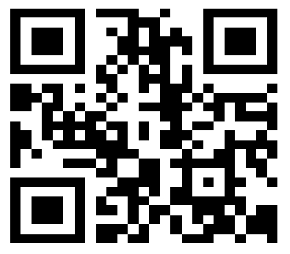

**Drawell International Technology Limited**

**Shanghai Drawell Scientific Instrument Co.,Ltd.**

**Chongqing Drawell Instrument Co.,Ltd.**

Add:Suite 2705,Building No.12,Shiyou Road No.1,Yuzhong District, Chongqing,China

Tel: 0086-023-63268643

Web : [www.drawell.com.cn](http://www.drawell.com.cn)

Email : [sales05@drawell.com.cn](mailto:sales05@drawell.com.cn)