Benchtop Meter-Classic series
User Manual



Please read operating manual before installation and operation.

Drawell International Technology Limited
Chongqing Drawell Instrument Co., Ltd.
Shanghai Drawell Scientific Instrument Co.,Ltd.

Address : Suite 2705,Building No.12,Shiyou Road No.1, Yuzhong District, Chongqing China.
Homepage : www.drawell.com.cn
Tel : 0086-023-63268643
Email : sales05@drawell.com.cn

- PH100 Benchtop pH/mV Meter
- EC100 Benchtop Cond/Res./TDS/Sal Meter
- DO100 Benchtop DO Meter (polarographic type)
- PC100 Benchtop pH /Cond Meter
- PD100 Benchtop pH /DO Meter (polarographic type)
- CD100 Benchtop Cond /DO Meter (polarographic type)
- PCD100 Benchtop pH /Cond/DO Meter (polarographic type)
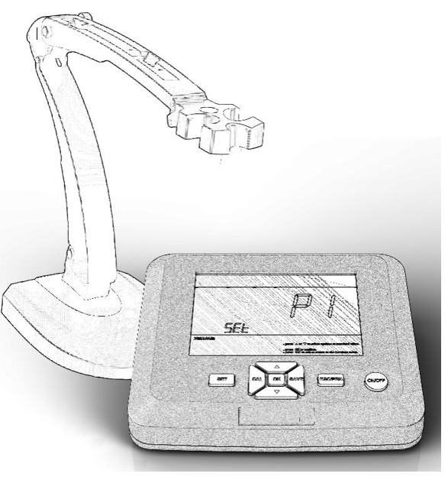

INDEX
1. Overview 3
1.1 Package Content 3
1.2 Features 4
2. Technical Specifications 5
3. Descriptions 6
3.1.1 LCD Display Interface 6
3.1.2. Meter Sockets 6
3.1.3 Operation Keys 7
4. pH Module 8
4.1 Before use 8
4.2 pH calibration 8
4.3. pH Measurement 8
4.4. pH Measurement Notes 8
4.5. Setup pH Programs 10
5. ORP Measurement 11
5.1 ORP Measurement 11
5.2 ORP Measurement notes 11
6. Conductivity module 12
6.1. Conductivity calibration (standard solution calibration method) 12
6.2. Measurements 12
6.3. Notes about the conductivity 12
6.4. Setup Conductivity Programs 14
7. DO Module 15
7.1. DO Calibration 15
7.2. DO Measurement 16
7.3 Notes about the DO test 16
7.4 DO sensor cap replacement 16
7.5 Setup DO programs 17
8. Data Management 18
9. Data transfer-Printer 18
10. Data transfer-USB stick 19
11. Warranty 19
12. Appendix A： Content of Saturated Oxygen in water at different temperatures 20
13. Appendix B：Content of Saturated Oxygen at different air pressure 21
14. Appendix C: Content of Saturated Oxygen at different altitude 22
15. Appendix D: Troubleshooting 23

Notes
To avoid the automatic temperature compensation error, should disconnect other probes not in use when conduct measurement.

Overview
Thank you for purchasing and using the classic series Benchtop pH/Cond/DO meter (hereinafter referred to as the instrument).
Be sure to read this manual before using the product to ensure proper and safe operation of the product. Also, safely store the manual so it is readily available whenever necessary. Product specifications and appearance as well as the contents of this manual are subject to change without notice.

1.1 Package Content
Benchtop-Classic series |  |  | single parameter |  |  | multi-parameter
Model No. |  |  | PH100 | EC100 | DO100 | PC100 | PD100 | CD100 | PCD100
Package including | 1 | Instrument | ✓ | ✓ | ✓ | ✓ | ✓ | ✓ | ✓
Package including | 2 | Plastic ATC pH probe 201T | ✓ | - | - | ✓ | ✓ | - | ✓
Package including | 3 | Plastic ATC Cond probe CON201T | - | ✓ | - | ✓ | - | ✓ | ✓
Package including | 4 | Polarographic DO probe  DO01-2M cable length:2m | - | - | ✓ | - | ✓ | ✓ | ✓
Package including | 5 | pH buffer solution:  50mL pH4.00/7.00/10.01 1 pc | ✓ | - | - | ✓ | ✓ | - | ✓
Package including | 6 | Cond standard solution:  50mL 84μS/1413μS/12.88mS/cm ea | - | ✓ | - | ✓ | - | ✓ | ✓
Package including | 7 | DO Membrane refill solution, 30mL,1btl | - | - | ✓ | - | ✓ | ✓ | ✓
Package including | 8 | DO Membrane sensor caps DOSC: 3pcs/group, 1pkg | - | - | ✓ | - | ✓ | ✓ | ✓
Package including | 9 | Power Adapter：1pc | ✓ | ✓ | ✓ | ✓ | ✓ | ✓ | ✓
Package including | 10 | Electrode holder: F01 | ✓ | ✓ | ✓ | ✓ | ✓ | ✓ | ✓
Package including | 11 | Carrying case:  (L×W×H: 49×28×8.5cm) | ✓ | ✓ | ✓
Package including | 12 | Carrying case:  (L×W×H: 48×36.5×8.5cm) |  |  |  | ✓ | ✓ | ✓ | ✓
Package including | 13 | Operation Manual | ✓ | ✓ | ✓ | ✓ | ✓ | ✓ | ✓

1.2 Features
  - 7″ large LCD display screen, easy to read.
  - Built-in microprocessor chip, with automatic calibration, data storage, function setting, data export and other functions, the instrument circuit board adopts SMT patch process, which improves the reliability of product performance.
  - Adopts digital filtering and slip technology to intelligently improve the response speed of the instrument and the accuracy of measurement data.

  - When the measurement is stable, the smile icon appears, and you can lock the reading manually or automatically.
  - pH module: automatic temp compensation, auto calibration, auto recognize pH buffer solution series, as USA/NIST/CN; Cal points:1-3pts.
  - Cond module: automatic temp compensation, auto calibration, auto recognize standard solution, switch measurement unit: Cond/RES/TDS/SAL, unique 1-pt conductivity calibration covering a wide range of 0 to 200mS, easy to use.
  - Dissolved Oxygen module: the polarographic DO has a built-in temp sensor, auto temp compensation, auto air pressure compensation. Each DO electrodes comes with three backup membrane caps, convenient for long-term use.
  - This meter is compatible with a wireless printer for the direct data print. (the printer is optional).

Technical Specifications
2.1. pH
Measurement range | (-2.00-20.00) pH
Resolution | 0.1/0.01 pH
Accuracy | ±0.01pH ± one digit
ATC range | (0-100)℃ (Automatic/Manual)
2.2 ORP (mV)
Measurement range | -1999 mV-0-1999 mV
Resolution | 1mV
Accuracy | ±0.1%FS±one digit
2.3 Conductivity (TDS/Sal/Resistivity)
Measurement  range | Cond: 0-200.0 mS/cm (auto-ranging)  (0.00-19.99) μS/cm, (20.0-199.9) μS/cm，  (200-1999) μS/cm, (2.00-19.99) mS/cm，(20.0-199.9) mS/cm  TDS: (0-100) g/L；Salinity: (0-100) ppt；Resistivity: (5-100.0) MΩ·cm
Resolution | 0.01/0.1/1μS/cm，0.01/0.1 mS/cm
Accuracy | ±1.0% FS ±one digit
ATC range | (0-50)℃ (Automatic/Manual)
Electrode constant | 0.1 / 1.0 / 10. cm⁻¹
Reference temperature | 25℃、20℃、18℃
2.4 DO
Measurement  range | (0-20.00) mg/L(ppm)；(0-200. 0)%
Resolution | 0.1/0.01 mg/L(ppm)，1/0.1%
Accuracy | ±0.30mg/L
Response time | 30s≤ (25℃,90% Respond)
residual current | ≤0.1 mg/L
ATC range | (0-50)℃ (Automatic/Manual)
Barometric pressure compensation range | (0-200) kPa (Automatic)
Salinity compensation range | (0-45) ppt (Manual)
Calibration | Air saturated water or water saturated air
Electrode type | Polarographic type
2.5 Other parameters:
Data storage | 450 readings  (Number, numerical value, unit, temperature, and time)
Power supply | DC12V
Packing size | 48×36.5×8.5cm

Descriptions

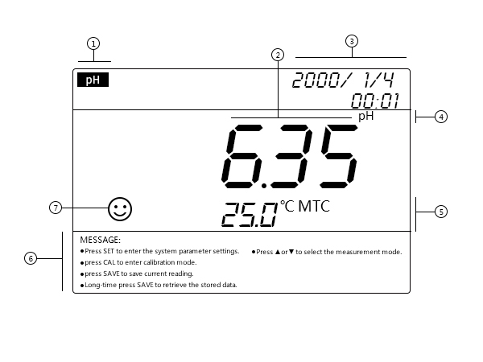

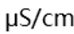
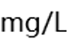

3.1.1 LCD Display Interface
- ------ Parameter mode icon
- ------ Measurement readings
- ------ Real time clock
- ------ Measurement unit
- ------ Temperature compensation mode
MTC: manual temperature compensation
ATC: automatic temperature compensation
- ------ Operation guide
- ------ Measurement stability icon
- ------ Calibrated points
- ------ pH electrode sensitive level

⑨


3.1.2. Meter Sockets

3.1.2 Meter socket
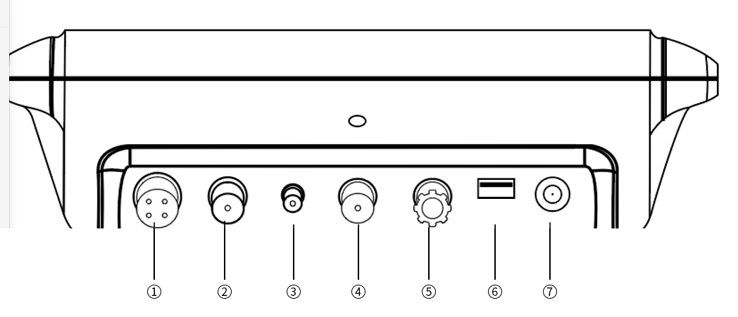

⑤ ----Connect reference electrode
⑥ ---- Connect USB Stick
⑦ ---- Connect Power adaptor (DC12V)
- ---- Connect conductivity electrode socket (4pins）
- ---- Connect pH electrode (BNC, Q9）
- ---- Connect temperature electrode (BNC, mini-BNC)
- ---- Connect DO electrode (BNC, Q9)

3.1.3 Operation Keys
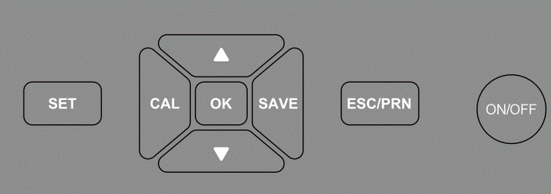
Long press：time>3S；Short press：time<1S

No. | Key | Function
1 |  | Power On/Off
2 |  | In the measurement mode, press to enter the parameter setting mode
3 |  | In the measurement mode, press to enter the calibration mode  • In setting the time: press to move the decimal point to left.  • In manual temperature compensation: press to move the decimal point to left
4 |  | • In measurement mode, press to print data (via a Bluetooth printer)  • In parameter setting/calibration mode, press to exit
5 |  | • In measurement mode, short press (shorter than 1s) to switch among different measurement modes: pH→COND→DO  •In parameter setting mode, press to change value
6 |  | •In each measurement mode, short press to enter the submenu:  pH mode: pH-mV  Cond mode: COND→RES→TDS→SAL  DO mode: mg/L-ppm- %-mg/L  •In parameter setting mode, press to change value
7 |  | Press to confirm selection
8 |  | •In the measurement mode, press to save data when the measurement stability icon stays one the screen. (“M+” flashes for one second at the bottom right.)  •In the measurement mode, long press to review the saved data. (RM and the number show up in this mode)  • In setting the time: press to move the decimal point to right.  • In manual temperature compensation: press to move the decimal point to right

pH Module

4.1 Before use
4.1.1 Press key to power on.
4.1.2. Before first-time use, please check the following settings and make adjustments: temperature unit, date, time, pH resolution, pH buffer series, etc. For details, refer to section 4.5
4.1.3. Connect the pH electrode to the meter socket,
- ATC: automatic temperature compensation;
- MTC: manual temperature compensation, If the manual temperature compensation is selected during measurement, you can leave the temperature socket (mini-BNC) empty, then the screen displays MTC, the manual temperature compensation temperature adjustment method refers to the 4.5 pH parameter setting P8);
4.1.4 Loosen the soaking cap from the electrode tip, and rinse the electrode in deionized water., remove the electrode protection bottle and the electrode protection bottle cap respectively.

4.2 pH calibration
4.2.1. Pour certain pH7.00 buffer solution in the sample vial.
4.2.2 Press to enter the calibration mode, "C1" appears on the screen, reminds of the first point calibration.
4.2.3. Rinse the electrode in pure water and shake it dry, immerse it into the pH7.00 buffer solution (the front tips of the electrode should be immersed higher than 1.5cm). Gently stir the electrode in pH7.00 buffer solution, let it stand, press to confirm the calibration when the smile icon stays on the screen, the first calibrated symbol ① is displayed on the left, the first point calibration is conducted.
4.2.4. Following the above steps, press key to conduct the 2nd point and 3rd point calibration with buffer solution pH4.00 and pH10.01
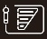
4.2.5 When the three points calibration conducted, press to exit the calibration mode, and the meter enters the measurement mode, the calibrated points ①②③and the pH electrode sensitive level displays on left of the screen

4.3. pH Measurement
- After calibration, rinse the electrode in pure water and shake-dry.
- Immerse the electrode in sample solution, stir gently, let it stand still, get the readings when the smile icon stays on the screen.

4.4. pH Measurement Notes
- For the most accurate pH measurements, the temperature of the sample solution and the calibration solution should be as the close.
- The tester is calibrated at the factory. (the calibrated points and electrode sensitive level icon stays on the screen). You can perform 1 to 3-pt calibration with a known, reliable pH buffer solution as required. The pH7.00 is suggested for the 1st point calibration, then followed by the acid (pH4.00) or alkaline (pH10.01) point calibration. If you`d like to perform a two-point calibration, the 2nd pH buffer solution should cover the sample solution pH value. For example, if the pH value of the sample solution is known as pH5, using a pH4.00 buffer solution would be best. The meter can automatically recognize the buffer solution as the following:
Cal points | USA | NIST | CH | Recommended
1 point | 7.00pH | 6.86pH | 6.86 pH | ≤ ±0.1pH
2 points | 7.00pH/4.00pH | 6.86pH/4.01pH | 6.86pH/4.00pH | <7.00 pH
2 points | 7.00pH/10.01pH | 6.86pH/9.18pH | 6.86pH/9.18pH | >7.00 pH
3 points | 7.00pH/4.00pH/10.01pH | 6.86pH/4.01pH/9.18pH | 6.86pH/4.00pH/9.18pH | 0~14.00pH
- Do not pour the solution back after use to avoid contamination.
- Strong acid, strong alkali, and organic solutions will accelerate the aging of the electrode bulb and the plastic shell solvent. Please avoid testing such substances.
- The frequency of calibrating a pH meter depends on the sample solution tested, electrode performance, and the requirement of the accuracy. The higher the usage and the amount of contamination, the more often you need to calibrate your pH meter. For high-accuracy measurements (≤ ±0.02pH), it is necessary to perform calibration before every test. For the general accuracy (≥±0.1 pH), once calibrated, the meter can be used for a week or longer. In the following cases, it is advisable to calibrate your pH meter:
- When you use a new electrode or when the electrode hasn’t been used for a long time.
- After the electrode has been cleaned.
- After measuring a strong alkaline solution or a strong acidic solution.
- After measuring the fluoride-containing solution or organic solution.
- There is a significant temperature difference between the test sample and the buffer solution.
- Restore the meter to factory default settings.
- The electrode is immersed in 3mol/L KCl pH/ORP soaking solution to keep the pH membrane sensitivity. If the electrode storage solution is contaminated, please wash the bottle clean and fill in new storage solution.
- Always keep the electrode connector clean and dry. Use cotton balls with isopropyl alcohol to clean if it gets dirty, and then blow-dry it. This is to prevent a potential short circuit, which will undermine the electrode’s performance.
- There occasionally would be some white KCL crystals surrounding the electrode protective cap after long-term storage, this is a normal phenomenon and will not affect the electrode performance. Just rinse it in deionized water.
- Every pH electrode undergoes a natural aging process. With aging, the responding behavior becomes slower and slower, and the electrode slope and asymmetry change. Moreover, extreme operating conditions can considerably shorten the lifetime of the electrode. For serious passivation, the user could renew the electrode by submerge the electrode tips in 4%HF (hydrofluoric acid) for around 5-8 seconds, rinse it in deionized water, and then submerge in pH soaking solution for at least 30 minutes to renew it. If the probe still fails calibration, please replace a new one.
- Besides the general contamination cleaning, you can clean contaminated glass bulbs and junction as below.
Contamination | Cleaning Solution
Inorganic metal oxide | Diluted acid less than 1mol/L
Organic lipid | Dilute detergent (weak alkaline)
Resin macromolecule | dilute alcohol, acetone, ether
Proteinic haematocyte sediment | Acidic enzymatic solution (saccharated yeast tablets)
Paints | Dilute bleacher, peroxide
Note:
HF (Hydrofluoric acid) is highly toxic and should be handled with caution in a fume hood.
Note
Never store the pH electrodes in pure water such as RO water, tap water, distilled water, deionized water, or organic solution as they will cause damage to the electrode.
Never rub the electrode tip with a cloth or hand, this will introduce an undesirable static electricity into the glass shaft of the electrode and prolong the response time considerably.
- When the instrument does not work well in calibration or measurement, you can enter the parameter setting P7 to restore the instrument to the factory default setting. Calibrate and measure again after setting the instrument back to factory default.

4.5. Setup pH Programs

Parameter | Code | Parameter Setting Items | Parameter
P1 | 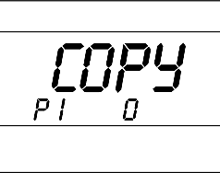 | Data Export | Press , when a USB stick connected. otherwise, the Err1 will appears instead.
P2 | 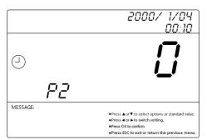 | Date/Time Settings | Press or to change the value, press to move left, pressto move right, press to confirm the change.
P3 | 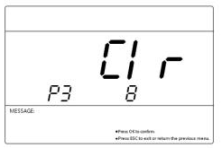 | Clear Records | Press to clear the records.
P4 | 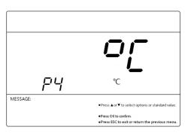 | Temperature unit | Press or to select ℃ / ℉
P5 | 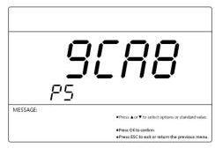 | Check meter code | -
P6 | 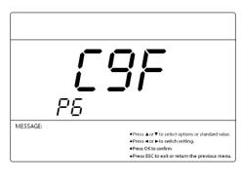 | Check the authorization code | --
P7 | 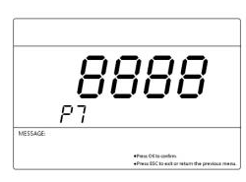 | Restore to factory default settings | press to confirm, 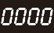 flashes,  the meter restored to factory default settings
P8 | 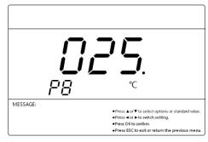 | Set manual temperature compensation | Press or to change the value,  press to move left, pressto move right,  press to confirm the change.
P9 | 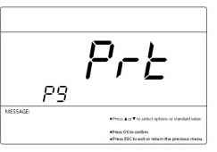 | Bluetooth connection | Default settings: Bluetooth connected
P10 | 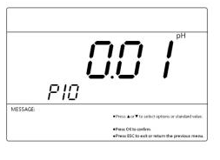 | pH resolution | Press or select pH resolution: 0.1/0.01
P11 | 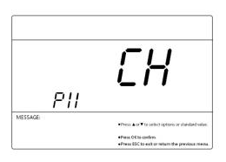 | pH buffers solution series | CH：1.68 pH, 4.00 pH, 6.86 pH, 9.18 pH, 12.46pH  NIS：1.68 pH, 4.00 pH, 6.86 pH, 9.18 pH,12.46pH  USA：1.68 pH, 4.00 pH, 7.00 pH, 10.01 pH, 12.45pH
P12 | 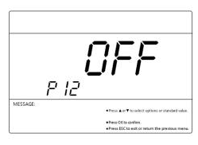 | Purified water measurement | 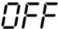 general samples  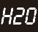 Purified water compensation  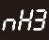 Ammonized purified water compensation

ORP Measurement

5.1 ORP Measurement
- Pressto power on, press to enter the pH mode, press to select ORP mode.
- Connect the ORP electrode to the BNC socket, screw off the electrode storage cap, rinse the front tip of the electrode in purified water, and shake-dry.
- Immerse the electrode in sample solution, stir gently, let it still, get the readings when the smile icon stays on the screen.

5.2 ORP Measurement notes
  - In ORP measurement, there is no need of temperature compensation. (CAL key will not activated in the ORP mode. If there`s doubt about the quality of the ORP electrode or the test results, you can use the ORP standard solution to test its mV value to determine whether the ORP electrode or instrument is accurate or not.
  - The surface of the ORP measurement electrode (platinum or gold) should be bright. When the electrode used over a long period, the platinum surface will get polluted, which causes inaccurate measurement and slow response. In this case, please refer the following methods for cleaning and activation:
- For inorganic pollution, immerse the electrode in 0.1mol/L dilute hydrochloric acid for 30 minutes, washed with pure water, and then immerse it in the pH soaking solution for 6 hours before use.
- For organic oil and oil film contamination, clean the platinum surface with detergent, then rinse the electrode in pure water. After that, submerge the electrode in electrode soaking solution for 6 hours before use.
- For heavily polluted platinum surface on which there is oxidation film, polish the platinum surface with toothpaste, then wash it in distilled water, then submerge it in the 3mol pH/ORP soaking solution for 6 hours.

Conductivity module

6.1. Conductivity calibration (standard solution calibration method)
- Press to power on, press to enter COND measurement mode.
- Connect the Cond electrode to the Cond socket (4-pins). The meter shows ATC automatically.
- Press to enter calibration mode.
- Rinse the electrode in purified water, and shake-dry.
- Immerse the electrode in 1413μS/cm standard solution, stir gently and let it stand, press to confirm the calibration when the smile icon stays on the screen (The Err will shows up when the reading is not stable.).
- Press to enter measurement mode, and the calibration icon displays on the screen.

6.2. Measurements
- After calibration, rinse the electrode in pure water and shake-dry.
- Submerge the electrode in sample solution, stir gently, let it stand still, get the readings when the smile icon stays on the screen.
In the conductivity measurement mode, press to select other mode, as RES/TDS/SAL.

6.3. Notes about the conductivity
- The tester is calibrated at the factory. You can use directly.
- The resistivity, TDS, and salinity is converted from conductivity, doesn't need to be calibrated. When needed, you can perform the conductivity calibration.
- For the normal use, it is advisable to calibrate the meter once a month or after being used for a period of time. Always keep the conductivity electrode rods clean. Before measurement, rinse it clean with pure water and shake-dry, and rinse it with the sample solution would be better.
- This instrument supports electrode constant calibration and standard solution calibration. Clause 6.1. is the way of standard solution calibration. When you have an accurate, reliable standard conductivity solution, the standard solution calibration method will be more accurate. If you are used to the constant calibration, you can set the electrode constant in the “Electrode constant” as in Section 6.4. Both methods can be selected arbitrarily and will not affect each other.
- In the parameter setting 6.4, there`s two series of the standard solution to choose from. as shown below.
USA: 84.0μS/cm, 1413μS/cm, 12.88 mS/cm, and 111.9 mS/cm
CH: 146.6μS/cm, 1408μS/cm, 12.85mS/cm, and 111.3mS/cm
- The instrument comes with three bottles of standard solution: 84μS/cm, 1413μS/cm, and 12.88mS/cm. The default conductivity electrode (K=1.0cm⁻¹) can be used within the range of less than 100 mS/cm after calibrating with a 1413μS/cm calibration solution. For the details, the user can make the choice according to the table below:
Measuring range | 0.05～20μs/cm | 0.5μs/cm～200ms/cm
Electrode constant | K=0.1cm⁻¹  (with a flow cell) | K=1.0cm⁻¹
Calibration solution USA series | 84μS/cm/ | 84μS/cm | 1413μS/cm | 12.88mS/cm, 111.9 mS/cm
Calibration solution CN series | 146.6μS | 146.6μS | 1408μS | 12.85mS, 111.3mS/cm
- The conductivity electrode is coated with a fluffy platinum black layer, to minimize the polarization effect and enlarge the measurement range. Therefore, Do Not wipe the platinum rod, you can rinse it in water or use warm detergent to clean the organic contamination, or use alcohol to clean it.
- Before use, the conductivity electrode is soaked in pure water, to prevent the platinum black to be passivated. If found the platinum black plated electrode is invalid, you can immerse it into 10% nitric acid solution or 10% hydrochloric acid for 2 minutes, then rinse it with purified water and again test. If the test still fails, the platinum black needs to be recoated, or replacing a new conductivity electrode.
- The default setting of the temp. compensation factor is 2.0%/˚C. User can adjust the factor based on sample solution and experimental data in parameter setting (see section 6.4). The following table is some examples for setting up the temp. compensation factor.
Solution | Temperature compensation coefficient
NaCl | 2.12%/℃
5%NaOH | 1.72%/℃
Dilute ammonia | 1.88%/℃
10% Hydrochloric acid | 1.32%/℃
5% Sulfuric acid | 0.96%/℃
Note:
When the coefficient for the temperature compensation is set to 0.00 (no compensation), the measurement value will be based on the current temperature.

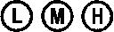
6.4. Setup Conductivity Programs
Parameter | Code | Parameter Setting Items | Parameter
P1 |  | Data Export | Press , when a USB stick connected. otherwise, the Err1 will appears instead.
P2 |  | Date/Time Settings | Press or to change the value, press to move left, pressto move right, press to confirm the change.
P3 |  | Clear Records | Press to clear the records.
P4 |  | Temperature unit | Press or to select ℃ / ℉
P5 |  | Check meter code | --
P6 |  | Check the authorization code | --
P7 |  | Restore to factory default settings | press to confirm, flashes, the meter restored to factory default settings
P8 |  | Set manual temperature compensation | Press or to change the value,  press to move left, pressto move right, press to confirm the change.
P9 |  | Bluetooth connection | Default settings: Bluetooth connected
P10 | 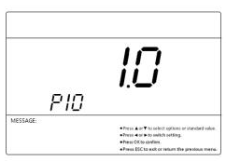 | Cond electrode constant | Presskey andkey to set the coefficient  press to move left, pressto move right, press to confirm the change.
P11 | 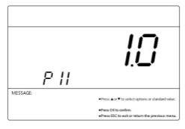 | Cond electrode constant | Select the conductivity constant among 1.0/10.0/0.1
P12 | 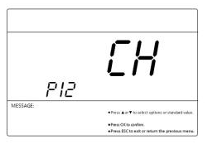 | Cond standard solution | USA series:  84.0μS/cm, 1413μS/cm, 12.88 mS/cm, and 111.9 mS/cm  CH series:  146.6μS/cm, 1408μS/cm, 12.85mS/cm, and 111.3mS/cm
P13 | 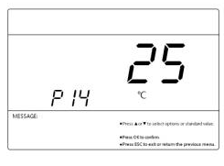 | Temperature compensation factor of the solution | 18℃ , 20℃, and 25℃

DO Module

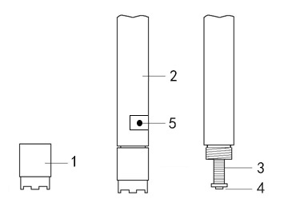
7.1. DO Calibration
7.1.1 Before use
- Check on the DO electrode: see the Diagram right. There should be no air bubbles in the electrode sensor cap. If there is. Screw off the sensor cap, and refill DO electrolyte full. (It is normal if there`s few DO electrolyte dripping during this process).
- Connect the DO electrode to the powered-on meter without measurement or calibrating. Let the electrode polarization consume the remaining oxygen inside the inner solution of the membrane cap so as to ensure fast response and high accuracy. The polarization time should be 15-30 minutes.
- DO sensor cap
- DO electrode shaft
- Anode (silver)
- Cathode (platinum)
- Temp. sensor
7.1.2 DO Calibration
Full Saturated oxygen calibration:
- Press to enter calibration mode.
- Place the electrode in air, wait for the green smile icon displays, press to confirm the calibration, and the “Full oxygen calibration completed” on the screen reminds of the calibration completed.
- The meter enters the measurement mode automatically.
In the DO measurement mode, press to select unit among ppm,%, mg/L
Zero oxygen calibration:
Usually there is no need to do zero oxygen calibration unless you have a high requirement for accuracy in low oxygen level (<1.0ppm) or you are replacing the DO electrode, DO sensor cap, and long term not in use. To do zero oxygen calibration, follow the steps below:
- Prepare 100mL of zero-oxygen water: In a 100 mL beaker, add in 5.0g anhydrous sodium sulfite (Na₂SO₃) and distilled water to 100 mL, mix well to dissolve. Note that the zero-oxygen water is only effective within 24 hours.
- Polarize the meter for 15 minutes, and calibrate the meter as Clause 7.1.2.
- Submerge the DO in zero oxygen water, enter the calibration mode, wait for the smile icon stays on the screen. press for calibration confirmation. The meter conducted the calibration in a few minutes. Rinse the electrode in pure water.
- If the reading is less than 0.02 ppm after 5 minutes, it means the electrode is in good condition and there is no need to perform zero oxygen calibration. Just press to return to measurement mode.
- If the reading is greater than 0.15 ppm after 5 minutes, it’s time to replace the membrane cap according to section 7.4 or remove the membrane cap and use a Super-fine polishing paper to lightly polish the platinum cathode according to section 7.4. Then perform the saturated air calibration and zero oxygen calibration before measurement.

7.2. DO Measurement
- In the flowing water (water speed >5cm/s): Power on the meter, place the DO electrode into the flowing water. The water surface should be higher than the location of temperature sensor. The angel between the electrode and the water surface should be around 45° to 75°, Hold the electrode and get the readings when the smile icon stays on the screen (typically takes 1-5 minutes).
- In the static water: Power on the meter, place the DO electrode into the flowing water，The water surface should be higher than the location of temperature sensor. The angel between the electrode and the water surface should be around 45° to 75°, move the electrode in water fast (>5cm/s) around 3-5 minutes. When the reading is fully stabilized, record the measurement (DO NOT stop the moving while recording the measurement).
Never stop the DO electrode from moving in static water while measuring. Otherwise, the Dissolved Oxygen in solution will be consumed continuously, the DO reading will keep dropping, and the DO readings will be lower than the actual.

7.3 Notes about the DO test
- When calibration, the temperature difference between the sample solution and the air should be the close(≤10℃), If the temperature difference is too large, you can immerse the DO electrode in the sample water for about 10 minutes, and then perform the calibration immediately.
- The electrode requires polarization after each power on. Do not turn off the meter when in use.
- Temperature impacts the DO measurement significantly. When the electrode temperature and water temperature have larger difference, the reading time must be greater than 3 minutes. Otherwise, there could be some large errors.
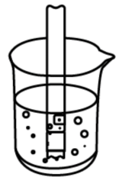
- To avoid the error caused by the inaccurate Temp. compensation, the surface of the water must be higher than the temperature sensor location as the right.
- When the meter performs abnormal, you can restore the meter to factory default settings, and conduct the calibration before measurement.
- Salinity and Barometric pressure compensation
The meter has manual salinity compensation and automatically barometric pressure compensation. For details, refer to Section 7.5.

7.4 DO sensor cap replacement
When the DO electrode’s response time becomes slower, obvious errors occur in measurement, or when the sensitive membrane of DO electrode is wrinkled, cracked or damaged at any extent (the well-functioning membrane surface should look perfectly smooth), it’s time to replace a new membrane cap according to the following steps.
- Screw off the membrane cap.
- Rinse the electrode without membrane cap with distilled water and shake-off excess water.
- Clean on the cathode surface (gold slice) with a clean tissue.
- Add new inner solution into a new membrane cap slowly and do not let any air bubbles appear. If you found any air bubbles in the cap, carefully flick on the membrane cap to eliminate them.
- Place the membrane cap on the table and put in the electrode vertically, slowly twist in, and then screw on the cap tightly. The excess inner solution will be squeezed out. Please wipe it off with tissue and rinse off the electrode in distilled water.

7.5 Setup DO programs
Parameter | Code | Parameter Setting Items | Parameter
P1 |  | Data Export | Press , when a USB stick connected. otherwise, the Err1 will appears instead.
P2 |  | Date/Time Settings | Press or to change the value,  press to move left, pressto move right, press to confirm the change.
P3 |  | Clear Records | Press to clear the records.
P4 |  | Temperature unit | Press or to select ℃ / ℉
P5 |  | Check meter code | -
P6 |  | Check the authorization code | -
P7 |  | Restore to factory default settings | press to confirm, flashes, the meter restored to factory default settings
P8 |  | Manual temperature compensation | Press or to change the value,  press to move left, pressto move right, press to confirm the change.
P9 |  | Bluetooth connection | Default settings: Bluetooth connected
P10 |  | DO resolution | 0.1/ 0.01
P11 | 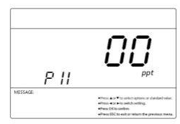 | Manual salinity compensation | Press or to change the value,  press to move left, pressto move right,  press to confirm the change.
P12 | 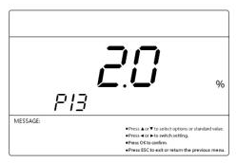 | Manual barometric pressure compensation | Press or to change the value,  press to move left, pressto move right, press to confirm the change.

Data Management
Data storage
In the measurement mode, short press to save the measurement.
Data review
In the measurement mode, long press to review the saved data. (RM and the number show up in this mode)
Data erase
This instrument can store up to 450 groups of data. When the storage room is full, please enter the parameter setting P3 to clear the readings.

Data transfer-Printer
9.1 the Bluetooth printer connection
- Power on the Bluetooth printer (the printer is optional), it will be automatically connected with the meter, and the yellow light on the printer flashes for a few seconds.
- After the printer is connected successfully, the yellow light will stay on instead of flashes.
9.2 Data printing
*****Instrument category*****
Year / month / day / time / minute Parameter:
Numeric value:
Temperature:
sign one's name:
*********END line *********
When the measurement is stable (the smile icon stays on the display screen)，press for the data printing, the format is as shown on the right.
Notes
Place the Bluetooth printer shorter than the distance of 10 meters.
If the meter fails printing, see the ways below for fix up:
- Check the power supply of the printer (whether the yellow light is always on or flashing alternately)
- Reboot the printer and the meter;
- Wait for the reading to be stable;

Data transfer-USB stick
- In the measurement mode, connect the USB stick to the USB socket;
- Press to enters P1，press to start data transfer；
- “COPY” flashes, and GOOD shows up shortly reminds of the data is stored to the USB stick. Pressto exit;
- If the Err 1 flashes, check whether the USB stick is well connected.

Warranty
The warranty covers (from delivery):
We warrant the tester against defects in material and workmanship when used in a normal manner for a period of two (2) years (12 months to the electrode).
Note: The electrodes are consumables, and the service life depends on careful maintenance, usage conditions, frequency of use, etc. Within 12 months from delivery, if the user finds that the electrode cannot be used due to processing and manufacturing problems when unpacking it for use, it can be repaired or replaced free of charge.
The limited warranty does not cover the following:
- Wear and tear to parts.
- Accidental damage, as the pH bulb broken from shocking.
- Misuse, uncarefully handling.
- Unauthorized maintenance, soldering, counterfeiting and others.

Appendix A： Content of Saturated Oxygen in water at different temperatures
Temp  ℃ | DO  mg/L | Temp  ℃ | DO  mg/L | Temp  ℃ | DO  mg/L
0 | 14.64 | 16 | 9.86 | 32 | 7.30
1 | 14.22 | 17 | 9.66 | 33 | 7.18
2 | 13.82 | 18 | 9.46 | 34 | 7.07
3 | 13.44 | 19 | 9.27 | 35 | 6.95
4 | 13.09 | 20 | 9.08 | 36 | 6.84
5 | 12.74 | 21 | 8.90 | 37 | 6.73
6 | 12.42 | 22 | 8.73 | 38 | 6.63
7 | 12.11 | 23 | 8.57 | 39 | 6.53
8 | 11.81 | 24 | 8.41 | 40 | 6.43
9 | 11.53 | 25 | 8.25 | 41 | 6.34
10 | 11.26 | 26 | 8.11 | 42 | 6.25
11 | 11.01 | 27 | 7.96 | 43 | 6.17
12 | 10.77 | 28 | 7.82 | 44 | 6.09
13 | 10.53 | 29 | 7.69 | 45 | 6.01
14 | 10.30 | 30 | 7.56
15 | 10.08 | 31 | 7.43

Appendix B：Content of Saturated Oxygen at different air pressure
Air pressure |  | DO（mg/L）
MmHg | kPa | 15℃ | 25℃ | 35℃
750 | 100.00 | 9.94 | 8.14 | 6.85
751 | 100.13 | 9.96 | 8.15 | 6.86
752 | 100.26 | 9.97 | 8.16 | 6.87
753 | 100.40 | 9.98 | 8.17 | 6.88
754 | 100.53 | 9.99 | 8.18 | 6.89
755 | 100.66 | 10.00 | 8.20 | 6.90
756 | 100.80 | 10.01 | 8.21 | 6.91
757 | 100.93 | 10.03 | 8.22 | 6.92
758 | 101.06 | 10.04 | 8.23 | 6.93
759 | 101.20 | 10.07 | 8.24 | 6.94
760 | 101.33 | 10.08 | 8.25 | 6.95
761 | 101.46 | 10.09 | 8.26 | 6.96
762 | 101.60 | 10.11 | 8.27 | 6.97
763 | 101.73 | 10.12 | 8.28 | 6.98
764 | 101.86 | 10.14 | 8.30 | 6.99
765 | 102.00 | 10.15 | 8.31 | 7.00
766 | 102.13 | 10.16 | 8.32 | 7.01
767 | 102.26 | 10.18 | 8.33 | 7.02
768 | 102.40 | 10.19 | 8.34 | 7.02
769 | 102.53 | 10.21 | 8.35 | 7.03
770 | 102.66 | 10.22 | 8.36 | 7.04
771 | 102.80 | 10.23 | 8.37 | 7.05
772 | 102.93 | 10.25 | 8.39 | 7.06
773 | 103.06 | 10.26 | 8.40 | 7.07
774 | 103.19 | 10.28 | 8.41 | 7.08
775 | 103.33 | 10.29 | 8.42 | 7.09

Appendix C: Content of Saturated Oxygen at different altitude
Altitude |  | Air pressure |  | DO | Altitude |  | Air pressure |  | DO
foot | meter | kPa | mmHg | mg/l | foot | meter | kPa | mmHg | mg/l
0 | 0 | 101.3 | 760 | 8.25 | 7500 | 2287 | 77.1 | 579 | 6.28
500 | 152 | 9934 | 746 | 8.09 | 8000 | 2439 | 75.63 | 568 | 6.16
1000 | 305 | 97.6 | 733 | 7.95 | 8500 | 2591 | 74.44 | 559 | 6.06
1500 | 457 | 95.87 | 720 | 7.81 | 9000 | 2744 | 72.97 | 548 | 5.94
2000 | 610 | 94.28 | 708 | 7.68 | 9500 | 2896 | 71.64 | 538 | 5.83
2500 | 762 | 92.54 | 695 | 7.54 | 10000 | 3049 | 70.17 | 527 | 5.71
3000 | 915 | 90.95 | 683 | 7.41 | 10500 | 3201 | 68.84 | 517 | 5.61
3500 | 1067 | 89.35 | 671 | 7.28 | 11000 | 3354 | 67.38 | 506 | 5.49
4000 | 1220 | 87.75 | 659 | 7.15 | 12000 | 3659 | 66.58 | 500 | 5.42
4500 | 1372 | 86.15 | 647 | 7.02 | 13000 | 3963 | 65.78 | 494 | 5.36
5000 | 1524 | 84.56 | 635 | 6.89 | 14000 | 4268 | 64.98 | 488 | 5.29
5500 | 1677 | 83.09 | 624 | 6.77 | 15000 | 4573 | 64.18 | 482 | 5.23
6000 | 1829 | 81.63 | 613 | 6.65 | 16000 | 4878 | 63.38 | 476 | 5.16
6500 | 1982 | 80.03 | 601 | 6.52 | 17000 | 5183 | 62.58 | 470 | 5.10
7000 | 2134 | 78.56 | 590 | 6.40 | 18000 | 5488 | 61.79 | 464 | 5.03
Conversion of mmHg to kPa:
mmHg×0.13333=kPa
e.g.
200 mmHg = 200 × 0.133 = 26.6 kPa.
DO_{pt}=P×DO_{t}÷760

Note：
DO_{pt}— DO concentration under temperature t, air pressure P, mg/L;
P — air pressure, mmHg;
DO_{t} — DO concentration under temperature t, air pressure 760mmHg, mg/L;
760 — air pressure, mmHg.

Appendix D: Troubleshooting
No. | Error | Reason | How to solve problem
1 | Can`t power on | The button is not responsive | Contact service providers
2 | Incorrect Temp. readings | The Temp. thermistor failure | Replace electrode
3 | Strokes missing | LCD screen defective | Contact the supplier
4 | No change in all solution readings | Short circuit of electrode | - Replace the new electrode  If no changes, contact the dealer for instrument repair
5 | Calibration failure | - Electrode aging  - Air bubbles surrounding the electrode shield  - Incorrect/Expired calibration solution | - Replace electrode  - Stir in the solution to remove the air bubble  - Suggest the first point calibration starts with pH7.00 and fresh solutions.
6 | the Conductivity Reads “0” | - No current flow tested | - Front tip of the conductivity electrode should be completely immersed in the solution.  - When placing conductivity electrodes in solutions, avoid placing them in "dead" corners.  - For the measurement of high-purified water, it must be measured in a flow cell, and the flow rate should not be too high.

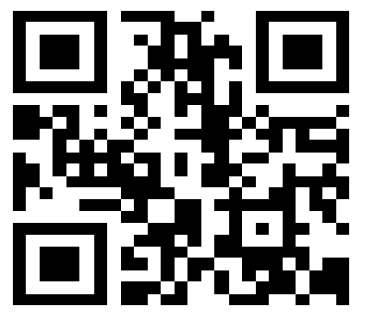
Drawell International Technology Limited

Shanghai Drawell Scientific Instrument Co.,Ltd.

Chongqing Drawell Instrument Co.,Ltd.

Add:Suite 2705,Building No.12,Shiyou Road No.1,Yuzhong District, Chongqing,China
Tel: 0086-023-63268643

Web : www.drawell.com.cn
Email : sales05@drawell.com.cn

