Benchtop Meter-Touch Screen
User Manual



Please read operating manual before installation and operation.

Drawell International Technology Limited
Chongqing Drawell Instrument Co., Ltd.
Shanghai Drawell Scientific Instrument Co.,Ltd.

Address : Suite 2705,Building No.12,Shiyou Road No.1, Yuzhong District, Chongqing China.
Homepage : www.drawell.com.cn
Tel : 0086-023-63268643
Email : sales05@drawell.com.cn

- PH100T Benchtop pH/mV Meter
- EC100T Benchtop Cond/Res./TDS/Sal Meter
- DO100T Benchtop DO Meter (polarographic)
- PC100T Benchtop pH /Cond Meter
- PD100T Benchtop pH /DO Meter (polarographic)
- CD100T Benchtop Cond /DO Meter (polarographic)
- PCD100TBenchtop pH /Cond/DO Meter (polarographic)
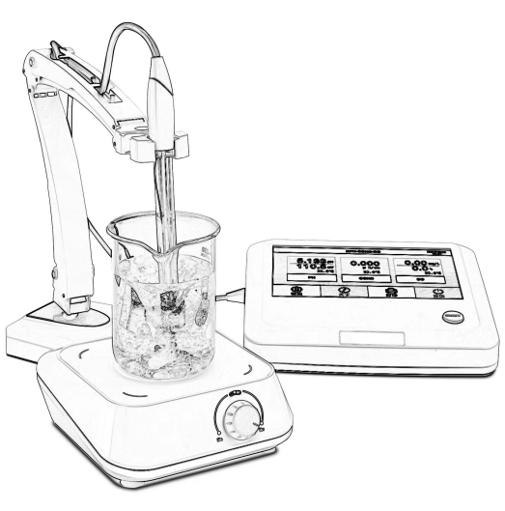

INDEX

1. Overview 4
1.1 Package Content 4
1.2 Features 5

2. Technical Specifications 6

3. Descriptions 8
3.1 LCD Display Interface 8
3.2 Meter Socket 8

4. Instrument Inspection 9

5. Operation 9
5.1 Basic parameter interface 9
5.2 Basic parameter Setup 10

6. pH Module 11
6.1 pH Interface 11
6.2 pH sub-Menu interface 12
6.3 pH sub-Menu Setup 13
6.4 pH Calibration、Measurement 13

7. Data Output：Bluetooth print 17
7.1 Printer connecting 17
7.2 Data printing 17
7.3 Notes 17

8. Data Output: USB stick 17

9. Data Output: PC 17

10. ORP Module 18
10.1 ORP Measurement 18
10.2 ORP Measurement notes 18

11. Conductivity Module 19
11.1 Conductivity main interface 19
11.2 Conductivity sub-Menu setup 20
11.4. Conductivity calibration, measurement 21
11.5 Notes 22

12. DO Module 24
12.1 DO Main interface 24
12.2 DO sub-Menu interface 25
12.3 DO sub-Menu setup 26
12.4 DO Calibration and Preparation 26
12.5 DO Measurement 27
12.6 Notes 27
12.7 DO sensor cap replacement 28

13. Warranty 29

Appendix：Troubleshooting 29

Appendix A：Content of Saturated Oxygen in water at different temperatures 30

Appendix B：Content of Saturated Oxygen at different air pressure 31

14. Appendix C: Content of Saturated Oxygen at different altitude 32

Overview
Thank you for purchasing the Touch Screen Series pH, Conductivity, Dissolved Oxygen Meter (hereinafter referred to as this instrument).
Before you use this instrument, please read the instruction manual carefully to help you use and maintain it correctly. We reserve the right to update the contents of this manual and accessories without prior notice for the purpose of continuous improvement of the instrument.

1.1 Package Content
Benchtop-Touch Screen series |  |  | Single parameter |  |  | Multi-parameter
Model No. |  |  | PH100T | EC100T | DO100T | PC100T | PD100T | CD100T | PCD100T
Package including | 1 | Instrument | ✓ | ✓ | ✓ | ✓ | ✓ | ✓ | ✓
Package including | 2 | Glass refillable pH electrode 201G | ✓ | - | - | ✓ | ✓ | - | ✓
Package including | 3 | Stainless steels Temp electrode TEMP-01 | ✓ | - | - | ✓ | ✓ | - | ✓
Package including | 4 | Glass Conductivity electrode CON201TG, K=1.0 | - | ✓ | - | ✓ | - | ✓ | ✓
Package including | 5 | Plastic DO electrode DO01-2M（polarographic） | - | - | ✓ | - | ✓ | ✓ | ✓
Package including | 6 | pH buffer solution:  50mL pH4.00/7.00/10.01 1btl for each | ✓ | - | - | ✓ | ✓ | - | ✓
Package including | 7 | Conductivity buffer solution:  50mL 84μS/1413μS/12.88mS/cm 1btl for each | - | ✓ | - | ✓ | - | ✓ | ✓
Package including | 8 | DOS-01 DO inner solution: 30mL, 1btl | - | - | ✓ | - | ✓ | ✓ | ✓
Package including | 9 | DOSC DO Membrane sensor caps,3pcs/group, 1pkg | - | - | ✓ | - | ✓ | ✓ | ✓
Package including | 10 | PC Data Cable, Power Adapter | ✓ | ✓ | ✓ | ✓ | ✓ | ✓ | ✓
Package including | 11 | Electrode holder F01 | ✓ | ✓ | ✓ | ✓ | ✓ | ✓ | ✓
Package including | 12 | Magnetic Stirrer | ✓ | ✓ | ✓ | ✓ | ✓ | ✓ | ✓
Package including | 13 | Carrying Case | ✓ | ✓ | ✓ | ✓ | ✓ | ✓ | ✓
Package including | 14 | Operation Manual | ✓ | ✓ | ✓ | ✓ | ✓ | ✓ | ✓

1.2 Features
This instrument adopts 1024*600 high resolution 7" TFT color LCD display, capacitive touch screen, more sensitive operation. It has the following features:
  - pH/Cond/DO measured values can be displayed simultaneously on separate screens.
  - Color LCD display, built-in microprocessor chip, with automatic calibration, data storage, function setting, data export and other functions.
  - Digital filtering and slip technology is adopted to intelligently improve the response speed of the instrument and the accuracy of the measured data，when the measured value is stable, the symbol  will show up.
  - pH module automatic temperature compensation, auto recognition of pH buffer solution, 3 standard buffers as: USA/NIST/CN, calibration points 1 - 5 points.
  - Timed measurement can be set, measurement value can be locked, reminder symbol：HOLD
  - Cond module measures RES、TDS、SAL，auto temp compensation, auto recognition of Cond calibration solutions, two calibration solutions can be selected: US and CH, can choose any point calibration.
  - DO module is equipped with polarographic dissolved oxygen electrode with built-in temp sensor, auto temp compensation, auto air pressure compensation, easy to use, accurate measurement, and supports manual salinity compensation. The electrode adopts combined diaphragm cap, which is very convenient to use, and each DO electrode is equipped with three spare diaphragm caps, which is convenient for users to replace.
  - This meter is compatible with a wireless printer for the direct data print. (the printer is optional).
  - Dust and waterproof grade：IP54

Technical Specifications
2.1 pH
Measurement Range | (-2.000-20.000) pH
Resolution | 0.01/0.001 pH
Accuracy | ±0.002pH±one digital
Input Current | ≤2×10⁻¹² A
Input Impedance | ≥1×10¹² Ω
2.2 mV
Measurement Range | (-1999.9 - +1999.9) mV
Resolution | 1mV
Accuracy | ±0.03% F.S ± one digital
2.3 Conductivity（TDS、Sal、Resistivity）
Measurement Range | 0-2000.0mS/cm, auto-ranging：  0-19.999μS/cm; 20.0-199.9μS/cm; 200-1999μS/cm;  2.00-19.99mS/cm; 20.00-199.9mS/cm; 200.0-2000mS/cm（K=10）  Match test range：0-200mS/cm  TDS: 0 - 100.0g/L（Factor adjustable）  Resistivity：5.000Ω·cm-100.0MΩ·cm, Sal: 0-100.0ppt
Resolution | 0.001
Accuracy | ±0.5 % FS± one digital
ATC range | （0-50）℃（Auto/Manual）
Electrode constant | 0.1 / 1.0 / 10. 0cm⁻¹
Reference temperature | 25℃、20℃、18℃

2.4 Dissolved Oxygen

Measurement Range | （0.00-20.00）mg/L；（0-200.0）%
Resolution | 0.1/0.01
Accuracy | ±0.30 mg/L
Response time | 30s≤(25℃,90%response)
residual current | ≤0.1 mg/L
Auto Temperature compensation range | （0-50）℃
Auto air pressure range | （0-200.0）kPa
Manual Salinity compensation | （0-45）ppt
Auto calibration | Air saturated water or water saturated air
Electrode type | polarographic

2.5 Other Parameters

Date Storage | 1500Groups(500Groups/Parameter)
Storage Content | No., parameter, value, unit, temperature, time
Power | DC12V, 300MA
Package Size | 55×38×8.5cm

2.6 Working Condition

Environmental temperature | 5-35℃（0.01grade）
Environmental humidity | ≤85%

Descriptions

3.1 LCD Display Interface

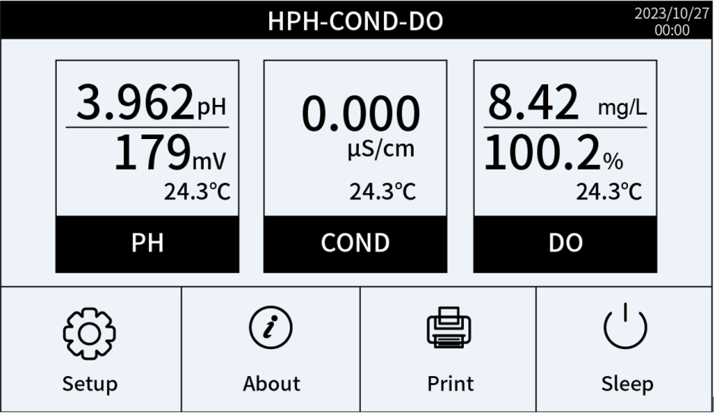
Real Time clock
Measurements
Functional area

3.2 Meter Socket

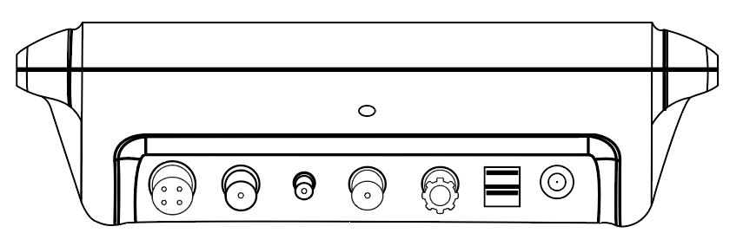
- ② ③ ④ ⑤ ⑥ ⑦ ⑧

⑤ ---- Reference electrode socket
⑥ ---- U flash drive socket
⑦ ---- PC connection
⑧---- Power adaptor（DC12V）
- ---- Conductivity electrode socket（4 Pins）
- ---- pH electrode socket（BNC,Q9）
- ---- Temp electrode socket(BNC,Q6）
- ---- DO electrode socket（BNC,Q9）

Instrument Inspection
- Checking packing list and the all parts inside of box；
- Check the appearance of the instrument, the electrode interface should be kept dry and clean, electrodes are not broken, etc.;
- Prepare the electrodes, calibration solutions, etc. according to test requirements；
- Install the electrode holder and plug the power cord into the power supply，long press to power on;

Operation

5.1 Basic parameter interface
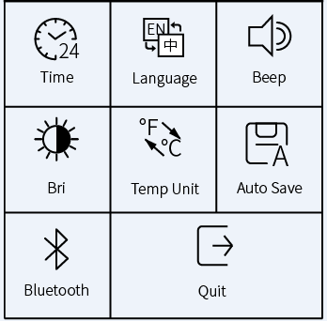
Long press ON/OFF power button，Click, 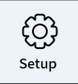 Display interface and sub-parameter interface ：
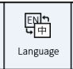
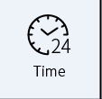
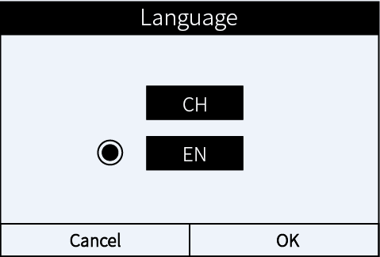
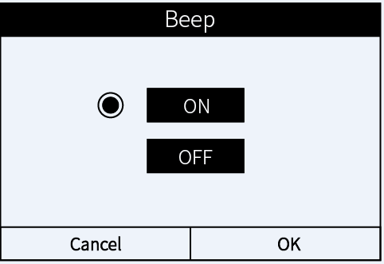
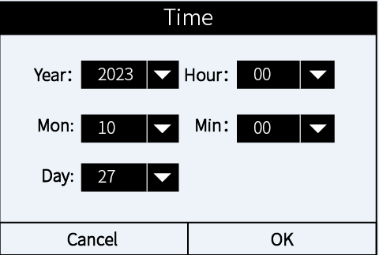
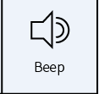

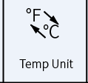
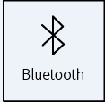
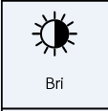
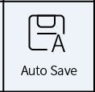
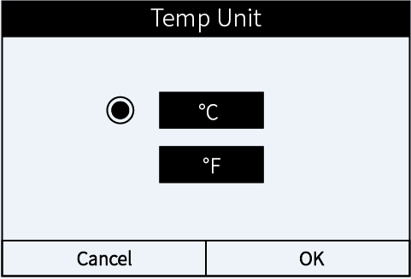
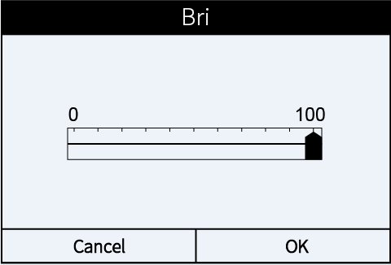
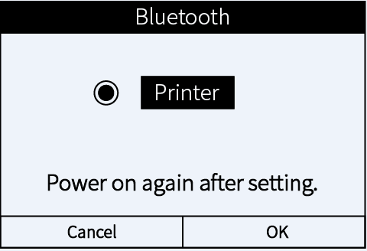
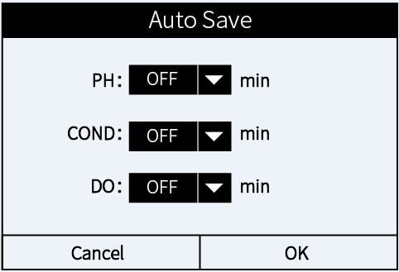

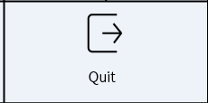
Exit the main interface

5.2 Basic parameter Setup
- Time：Change current time；content：Year/Mon/Day/Hour/Min，Click on the scroll bar below the arrow to change to the date of demand, then press OK to save, press Cancel to return
- Language：Select CH or EN according to the desired display interface, press OK to save, press Cancel to return.
- Beep：ON>turn it on，OFF>turn it off，press OK to save，press Cancel to return.
- Brightness：Adjust LCD backlight brightness, drag the scroll bar to set the brightness, press OK to save, press Cancel to return
- Temp Unit：℃/℉ selectable（Factory Default℃）；Unit℃ or ℉，press OK to save, press Cancel to return
- Auto Saving：Click on the scroll bar to select the automatic saving time for continuous measurement of each parameter.，OFF >cancel the auto saving
- Bluetooth: Factory setting default: printer mode
- Exit：Click Exit to return to main interface.

pH Module

6.1 pH Interface
Click icon pH and it shows as below:
- pH Measurement value
- Stable reminder symbol
Smiley face：Stable，
Red：Reading data
- Real Time
- Lock reading
- Slide to ORP module
- mV value corresponds to pH measurement reading
- Temp compensation module：
ATC：Auto temp compensation；
- MTC：Manual temp compensation
- Calibration solution series standard
- Calibration completed reminder symbol
- Electrode performance symbol
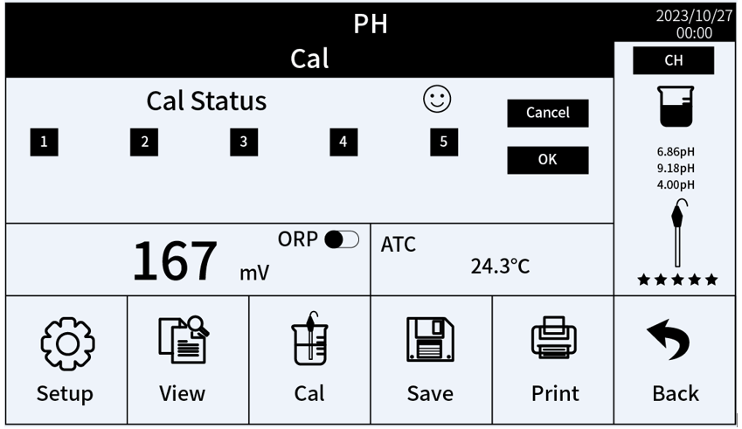

②
③
④
⑤
⑥
⑦
⑧⑨
⑩

6.2 pH sub-Menu interface
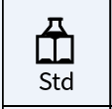
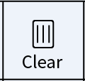
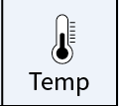
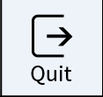
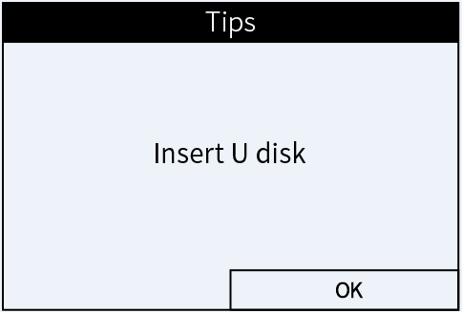
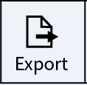
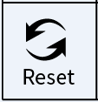
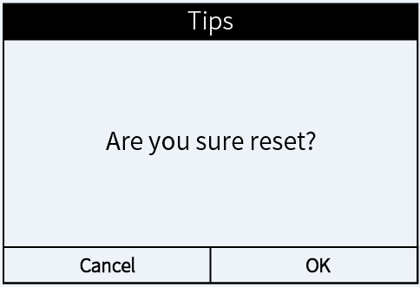
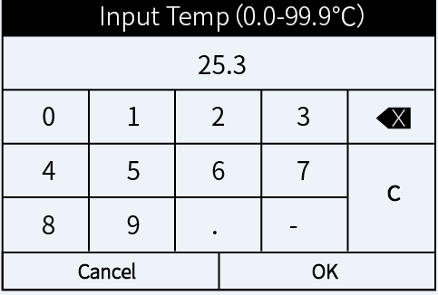
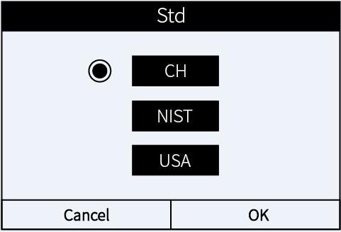
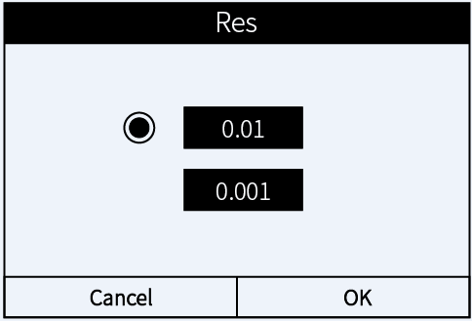
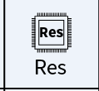
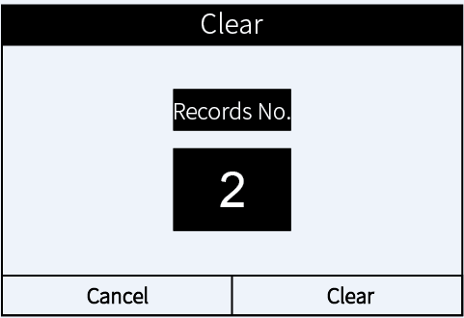
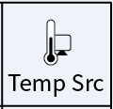
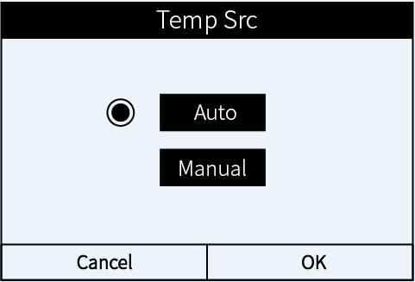
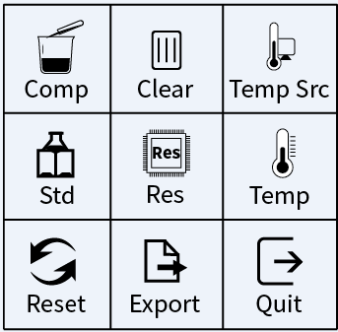
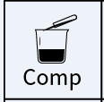
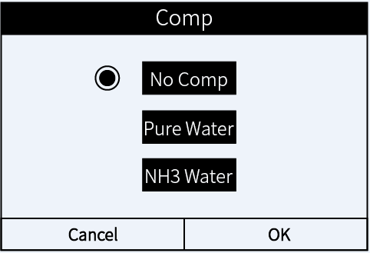
Press Setup to enter pH parameter settings, factory default setting as below:
Return to the measurement mode

6.3 pH sub-Menu Setup
- Comp：“No Comp”、“Pure Water”、“NH3 Water”three module；choose Setup，press OK to save, press Cancel to return
- Clear records：Clear all current records. Please press Clear to confirm, press Cancel to return；Note：This operation is irreversible, all records cannot be retrieved after erasure, so please be careful!
- Temp Src: “Manual” and “Automatic” two options are selectable. Notes：After selecting manual, pH measurement is manually temp compensated, even if the temp electrode is connected, you can choose to automatically switch to ATC auto temp compensation mode.
- Standard Solution Series：Select the standard, press OK to save up setting, press Cancel button to return.
- Resistivity：0.001pH and 0.01pH; select appropriate resistivity, press OK to save up the setting, press Cancel to return.
- Manual Temp：Input the actual temp of sample solution, press OK to save up the setting, press Cancel to return.
- Restore factory default：Restore to factory default setting，Notes:This operation is irreversible, all records cannot be retrieved after erasure, so please be careful!
- Data Output：Save the readings to U disk
- Exit: Press Exit to return to the test interface
- Query：Instrument save information contains: number, measurement value, mode, temperature value, save date. Press previous page, next page to turn the page, press clear to delete data, press Exit to return。

6.4 pH Calibration、Measurement
6.4.1 Preparation before calibration
Check the appearance of the glass pH electrode is normal or not. If the membrane is damaged, the electrode can not be used normally. If the membrane is dry, it needs to be soaked in 3moL KCL solution for 24 hours;
Check all the connector of instrument, connect the all-in -one glass body pH electrode and temp electrode in right way. (the following electrodes are referred to: all-in-one glass body pH electrode, temp electrode), about the temperature compensation reminder symbols:：
- ATC: When the temperature electrode is connected to the BNC (Q6) socket and it displays the reminder symbol ATC ；
- MTC：If manual temperature compensation is selected during measurement, there is no need to connect to this temperature socket, and the screen displays MTC, refer to 6.2 for manual temperature compensation temperature adjustment.）
Unscrew the protective bottle at the bottom of the pH electrode, remove the pH electrode and temp electrode and connect to the BNC (Q6) , the automatic temperature compensation reminder is displayed ATC , put the electrode into the buffer solution.
6.4.2 pH Calibration
Correct calibration is a must for accurate pH measurements, point 1 calibration is recommended to use pH 7.00 buffer solution (the following calibration procedure is based on buffer solution US Standard)
Click the icon  ，enter into pH calibration mode, (see right pic)，
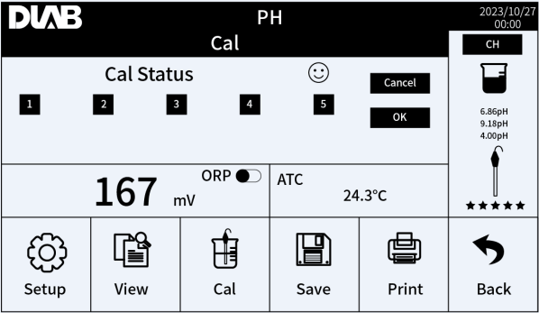
when "C1" appears on the screen, reminds of the first point calibration.
- Rinse the electrode in pure water and shake it dry, do not touch the pH membrane；
- Pour pH 7.00 calibration solution into the measuring cup;
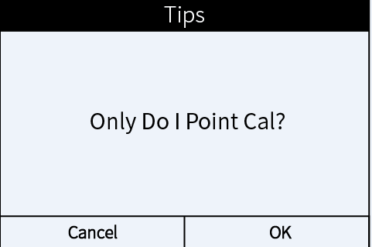
- Immerse the electrode in pH 7.00 buffer solution, shake it slightly and then let it stand, when the red icon on the upper right corner changes to the smiley face, that means the reading is stable，click confirm icon, the 1st point calibration completed, click cancel，the instrument will reminder that if you only need one point calibration (please see pic a)，click confirm，The instrument will return to the measurement mode, the right side of the LCD screen displays the calibration completed icon and the electrode performance status.
Pic a

Ltu
Ltu

- If you need more than one point of calibration, repeat the above steps 2-4 to calibrate with buffer solutions such as pH4.00/10.01，after more than 2 points calibration，the lower left corner of the screen displays the full calibration point icon and electrode performance status on the right side.
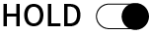
Notes： HOLD when you turn on the lock value function , the instrument can not calibrate, click close, then it can does calibration and measurement。
6.4.3 pH Measurement
- After calibration, rinse the electrode in pure water and shake dry.
- Immerse the electrode in sample solution, stir gently, let it stand still, get the readings when the smile icon stays on the screen. If you need lock the value, click HOLD，click HOLD again,The locking function is deactivated 。
6.4.4 pH Measurement Notes
- For the most accurate pH measurements, the temperature of the sample solution and the calibration solution should be as the close.
- The instrument automatically recognizes the calibration solution and can be calibrated at any point from 1 to 5. We’ve made 3 points calibration before leaving factory（it will show symbol when you power on）.If need another point calibration，The first point suggest using pH 7.00 or pH6.86 for zero calibration, and then a point 2 buffer solution that covers the predicted pH value of the sample is selected to ensure accuracy, e.g., if the sample is predicted to be pH 5.00, the buffer solutions need to be pH 7.00 and pH 4.00.
Cal points | USA | NIST | CH | Recommended
1 point | 7.00pH | 6.86pH | 6.86 pH | ≤ ±0.1pH
2 points | 7.00pH/4.00pH | 6.86pH/4.01pH | 6.86pH/4.00pH | <7.00 pH
2 points | 7.00pH/10.01pH | 6.86pH/9.18pH | 6.86pH/9.18pH | >7.00 pH
3 points | 7.00pH/4.00pH/10.01pH | 6.86pH/4.01pH/9.18pH | 6.86pH/4.00pH/9.18pH | 0-14.00pH
- Do not pour the solution back after use to avoid contamination.
- Strong acid, strong alkali, and organic solutions will accelerate the aging of the electrode membrane and the plastic shell solvent. Please avoid testing such substances.
- The frequency of calibrating a pH meter depends on the sample solution tested, electrode performance, and the requirement of the accuracy. The higher the usage and the amount of contamination, the more often you need to calibrate your pH meter. For high-accuracy measurements (≤ ±0.02pH), it is necessary to perform calibration before every test. For the general accuracy (≥±0.1 pH), once calibrated, the meter can be used for a week or longer. In the following cases, it is advisable to calibrate your pH meter：
- When you use a new electrode or when the electrode hasn’t been used for a long time；
- After measuring a strong alkaline(pH>12) solution or a strong acidic(pH<2) solution.
- After measuring the fluoride-containing solution or organic solution；
- There is a significant temperature difference between the test sample and the buffer solution。
- The protective cup at the front of the pH electrode contains an electrode soaking solution, in which the electrode head is immersed to maintain the activation of the glass membrane and the liquid junction. When measuring, loosen the cap, pull out the electrode and wash it with pure water to use. After use, the electrode will be inserted again and tighten the cap to prevent the solution from seeping out. If the soaking solution in the protective cup is found to be turbid and mouldy, it should be washed in time and replaced with a new soaking solution.
- Do put store the electrode in pure water, protein solutions and acidic fluoride solutions for a long time, and stay away from contact with organic oils and fats.。
- When the instrument is calibrated with a standard buffer solution of known pH value, the pH value of the buffer solution should be reliable in order to improve the measurement accuracy. The buffer solution should be replaced in time after repeated use.
- Keep the instrument clean and dry frequently, keep the instrument socket and electrode socket clean and dry, otherwise it will lead to inaccuracy or failure of measurement.
- The sensitive glass membrane of pH electrode should not be in contact with hard objects, any breakage and rubbing will make the electrode invalid. The electrode should be cleaned with pure water before and after measurement, and the electrode should be shaken dry or sucked dry after cleaning, do not rub the membrane with tissue, which will make the electrode potential unstable and extend the response time. After measurement in viscous specimens, the electrode needs to be repeatedly rinsed with pure water several times to remove the specimen stuck on the glass membrane, or first cleaned with a suitable solvent.
- After a long time using, or the measured solution contains substances that are easy to contaminate the sensitive glass membrane or block the liquid boundary, which will make the electrode passivated, and the phenomenon is that the sensitive gradient is reduced, the response is slow, and the readings are inaccurate, and the following measures can be taken according to the different situations：
- Glass membrane contamination aging: the electrode with 0.1mol / L dilute hydrochloric acid (preparation: 9mL hydrochloric acid diluted to 1000mL with pure water) soaked 24h, washed with pure water, and then the electrode soaking solution soaked for 24h. If the passivation is more serious can also be the electrode membrane in a 4% HF (hydrofluoric acid) solution soaked in (5 - 8) seconds, washed with pure water, and then in the electrode soaking solution soaked for 24h to renew it.
- Clean the glass membrane and ceramic junction contamination: (for reference)
Contamination | Cleaning Solution
Inorganic metal oxide | Diluted acid less than 1mol/L
Organic lipid | Dilute detergent (weak alkaline)
Resin macromolecule | dilute alcohol, acetone, ether
Proteinic haematocyte sediment | Acidic enzymatic solution (saccharated yeast tablets)
Paints | Dilute bleacher, peroxide

Notes：
    - Avoid Testing strong acids, alkalis or corrosive solutions. If testing such solutions, minimise the time of immersion and wash off carefully after use.
- Avoid use in dehydrating media such as anhydrous ethanol, concentrated sulphuric acid, etc., which can damage the hydrated gel layer on the surface of the pH electrode membrane.
- When the instrument is abnormal, the instrument can be restored to the factory setting state, and then calibrated and tested again.
- Click the symbol SAVE, current value can be saved，the saved infos contains serial number, measured value, mode, temperature value, and date.

Data Output：Bluetooth print

7.1 Printer connecting
Power on the Bluetooth printer (the printer is optional), it will be automatically connected with the meter, and the yellow light on the printer flashes for a few seconds. After the printer is connected successfully, the yellow light will stay on instead of flashes.

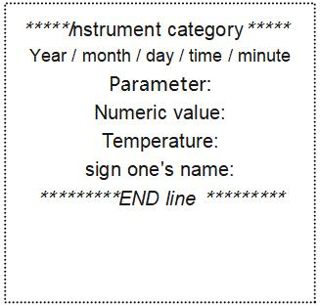
7.2 Data printing
After getting the stable measuring value，press  for data printing.
the format is as shown on the right.

7.3 Notes
Place the Bluetooth printer shorter than the distance of 10 meters.
If the meter fails printing, see the ways below for fix up:
- Check the power supply of the printer
- (whether the yellow light is always on or flashing alternately)
- Reboot the printer and the meter;
- Wait for the reading to be stable.

Data Output: USB stick

- In the measurement mode, connect the USB stick to the USB socket, the right corner will shows symbol .

- Click set-data button to enter，click the icon ;
- Click confirm to output the values

Data Output: PC
- After installing the software (please contact the supplier for the software), connect the PC cable to the PC socket of the instrument；
- Click Connect in the software interface to achieve the connection between the instrument and computer, and display the test screen synchronously;
- Click View, show all saved values；
- Click Export，Output of measured values to a specified location, output file format：.xls

ORP Module

10.1 ORP Measurement


    - Long press ON/OFF to power on，Click PH under the main screen, at this time mV is the mV value corresponding to the pH mode of the instrument, click to enter the ORP measurement mode, as right icon；
    - Connect the ORP electrode (Model: ORP301, optional), wash the electrode in pure water and shake it dry, immerse it in the solution to be measured, stir it slightly and then leave it at a standstill, wait until the measurement value stable and then take a reading.
    - For ORP (mV) measurement, the user only needs to read the value in the mV display area, the pH display value can be ignored.，

10.2 ORP Measurement notes
10.2.1 There’s no need to calibrate before ORP measurement (CAL key will not activated in the ORP mode. If there`s doubt about the quality of the ORP electrode or the test results, you can use the ORP standard solution to test its mV value to determine whether the ORP electrode or instrument is accurate or not.
10.2.2The surface of the ORP measurement electrode (platinum or gold) should be bright. When the electrode used over a long period, the platinum surface will get polluted, which causes inaccurate measurement and slow response. In this case, please refer the following methods for cleaning and activation:
- For inorganic pollution, immerse the electrode in 0.1mol/L dilute hydrochloric acid for 30 minutes, washed with pure water, and then immerse it in the pH soaking solution for 6 hours before use.
- For organic oil and oil film contamination, clean the platinum surface with detergent, then rinse the electrode in pure water. After that, submerge the electrode in electrode soaking solution for 6 hours before use.
- For heavily polluted platinum surface on which there is oxidation film, polish the platinum surface with toothpaste, then wash it in distilled water, then submerge it in the 3mol pH/ORP soaking solution for 6 hours.

Conductivity Module

11.1 Conductivity main interface
Click COND on the main interface and it will show as below pic.
③
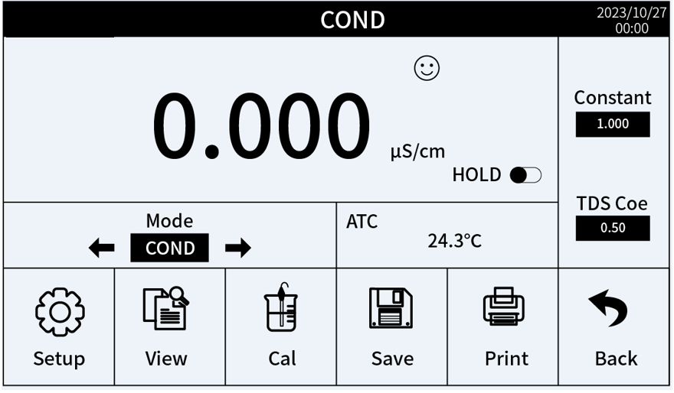
⑥
- Conductivity values
- Measurement stable reminder:
Smilely face：stable，
Red：reading the data
- Real Time
- Lock the readings
- Module change：COND/RES/TDS/SAL
- Temperature compensation：
ATC：Auto temp compensation；
MTC：Manual temp compensation
- Electrode constant/TDS ratio（Click to customize)
⑤
④
⑦
①
②
③

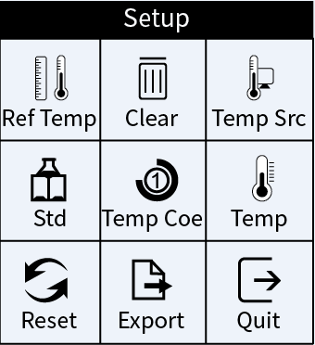
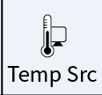
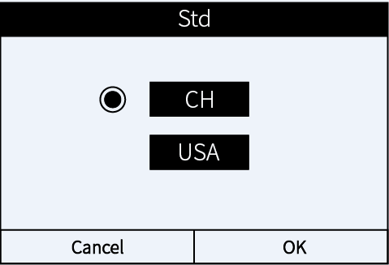
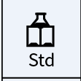
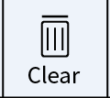
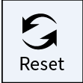
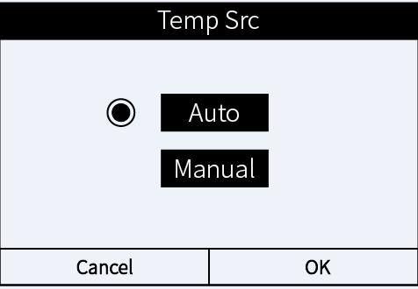
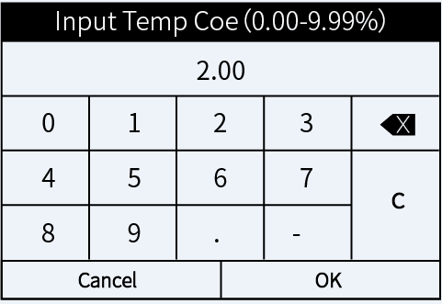
11.2 Conductivity sub-Menu setup
Return back to measurement mode
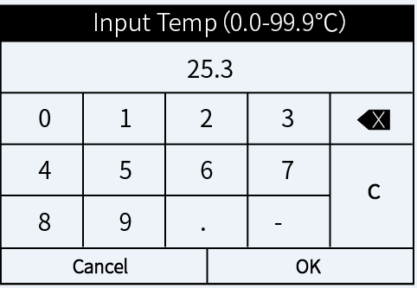
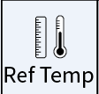
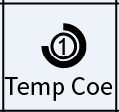
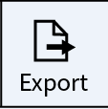
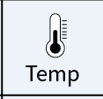
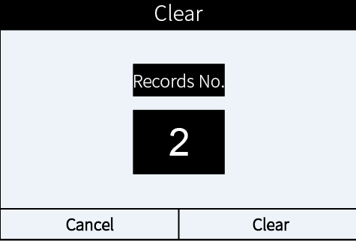
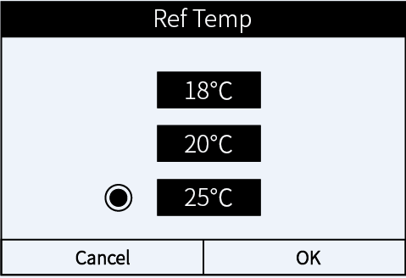
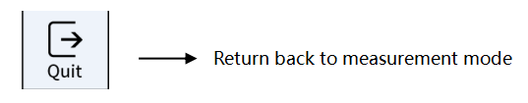
11.3 Conductivity sub-Menu setting method
- Standard Temp：“18℃”、“20℃”、“25℃”three options are selectable；select the temp and press OK to save the setting, press cancel to go back.
- Clear records：Clear all current records. Please press Clear to confirm, press Cancel to return；Note：This operation is irreversible, all records cannot be retrieved after erasure, so please be careful!
- Temp Src:“Manual”and“Automatic”two mode are selectable.
- Standard buffer series：CH/US/NIST three standards can be selected, select the demand standard and press OK to save the setting, and press Cancel to return.
- Temp compensation Coe：Press Temp Coef and put the compensated value（0.00-9.99%），press OK to save the setting, and press Cancel to return.
- Manual Temp：Manual temp setting range 0.0-99.9℃.
- Restore to factory default：Restore to the factory default setting，Note：This operation is irreversible, all records cannot be retrieved after erasure, so please be careful!
- Value Output：Saved to the U disk
- Exit : Press Exit to return to the test interface

11.4. Conductivity calibration, measurement
11.4.1 Preparation
- Check if there's any damage of the electrode , black platinum. rust will lead to the electrode can not be used normally, should be replaced with a new electrode use；
- Connect the electrode to the corresponded connector, take the US standard buffer as an example for below calibration。
11.4.2 Instrument calibration (standard solution calibration method)
- Long press ON/OFF to power on，click“calibration”，immerse the electrode into Cond standard solution 1413μS as reminder on the instrument. Shake gently and let it stand，wait until the dot icon turns to smilely face and then press calibration to complete the 1st point calibration. The instrument will go back to the measurement module，the right area of screen indicates the current electrode constant.
11.4.3 Sample Measurement
- Clean the electrode and shake it dry, immerse to the sample vial, Stir slightly and let it stand for few seconds, wait until the smilely face shows up then you can read the readings.
- Click“MODE”area of“←”or“→”，Cyclic display of conductivity, resistivity, TDS and salinity values.
- While you choose the constant of conductivity electrode k=10, the measurement range can be expand to 2000mS/cm。

11.5 Notes
- The tester is calibrated at the factory. You can use directly.
- The resistivity, TDS, and salinity is converted from conductivity, doesn't need to be calibrated. When needed, you can perform the conductivity calibration.
- There are two calibration methods for the conductivity electrode set up in this instrument: standard solution calibration method and constant calibration method. According to Article 7.2 of this example, when the precision of the standard solution is accurate, it can ensure the better accuracy of the instrument, so it is recommended that the user gives priority to the standard solution calibration method. If users are accustomed to the constant calibration method, that is, according to the constant value marked on the conductivity electrode calibration method, you can enter the constant in the electrode constant on the right side of the measurement interface (the new conductivity electrode constant has been calibrated accurately by the manufacturer, so the customer can rest assured that it can be used. If the electrode has not been used for a long time or is damaged, in order to ensure accuracy, clean the electrode first and then calibrate it with a standard solution). Both calibration methods can be chosen arbitrarily and will not affect each other.
- For the normal use, it is advisable to calibrate the meter once a month or after being used for a period of time. Always keep the conductivity electrode rods clean. Before measurement, rinse it clean with pure water and shake-dry, and rinse it with the sample solution would be better.
- The instrument comes with two kind of calibration solutions，refers to 11.2, choose from“standard solution series”
USA: 84.0μS/cm, 1413μS/cm, 12.88 mS/cm, and 111.9 mS/cm
CH: 146.6μS/cm, 1408μS/cm, 12.85mS/cm, and 111.3mS/cm
- The instrument comes with three bottles of standard solution: 84μS/cm, 1413μS/cm, and 12.88mS/cm. The default conductivity electrode (K=1.0cm⁻¹) can be used within the range of less than 100 mS/cm after calibrating with a 1413μS/cm calibration solution. For the details, the user can make the choice according to the table below:
Measuring range | 0.05-20μs/cm | 0.5μs/cm-200ms/cm
Electrode constant | K=0.1cm⁻¹  (with a flow cell) | K=1.0cm⁻¹
Calibration solution CN series | 146.6μS | 146.6μS | 1408μS | 12.85mS, 111.3mS/cm
Calibration solution USA series | 84μS/cm/ | 84μS/cm | 1413μS/cm | 12.88mS/cm, 111.9 mS/cm

- The conductivity electrode is coated with a fluffy platinum black layer, to minimize the polarization effect and enlarge the measurement range. Therefore, Do Not wipe the platinum rod, you can rinse it in water or use warm detergent to clean the organic contamination, or use alcohol to clean it.
- Before use, the conductivity electrode is soaked in pure water, to prevent the platinum black to be passivated. If found the platinum black plated electrode is invalid, you can immerse it into 10% nitric acid solution or 10% hydrochloric acid for 2 minutes, then rinse it with purified water and again test. If the test still fails, the platinum black needs to be recoated, or replacing a new conductivity electrode.
- The default setting of the temp. compensation factor is 2.0%/˚C. User can adjust the factor based on sample solution and experimental data in parameter setting.The following table is some examples for setting up the temp. compensation factor.
Solution | Temperature compensation coefficient
NaCl | 2.12%/℃
5%NaOH | 1.72%/℃
Dilute ammonia | 1.88%/℃
10% Hydrochloric acid | 1.32%/℃
5% Sulfuric acid | 0.96%/℃
Notes：When the coefficient for the temperature compensation is set to 0.00 (no compensation), the measurement value will be based on the current temperature.

- When there is abnormal phenomenon occurs in the instrument, the instrument can be restored to the factory setting state, and then calibrated and measured again.
Query、Save、Print： Refers to the pH section

DO Module

12.1 DO Main interface
Click DO on the main interface and it will show as below:
⑤
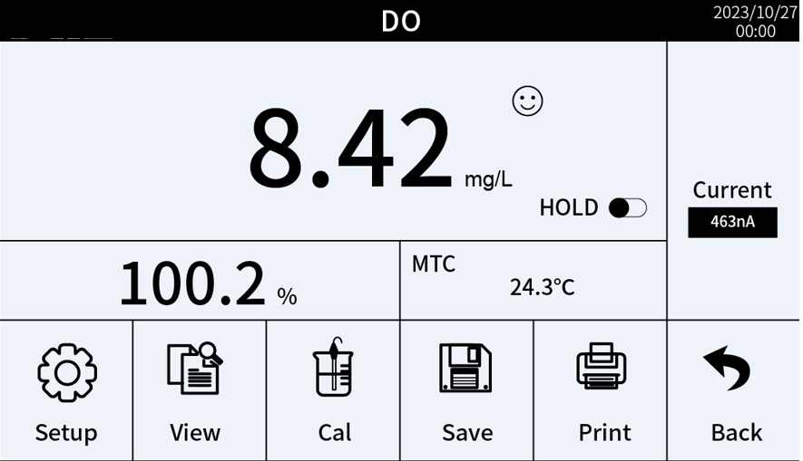
- DO Measurement values
- Percentage measurement data display screen
- Temp compensation mode：ATC：Auto Temp compensation；
- Measurement values stable symbol：
- Smilely face 😁>>stable，
- Red>> Reading the values
- Real Time
- Lock the reading.
- Current value induced by the electrode when testing the sample
①
④
③
②
⑦
⑥

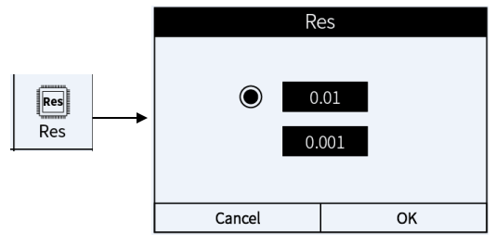
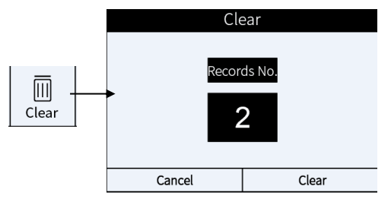
12.2 DO sub-Menu interface
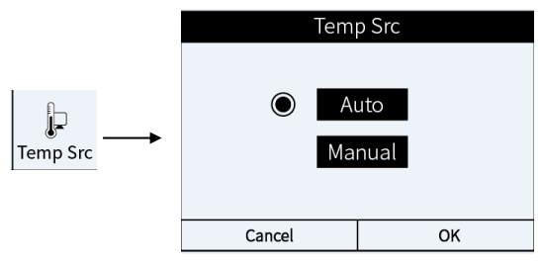
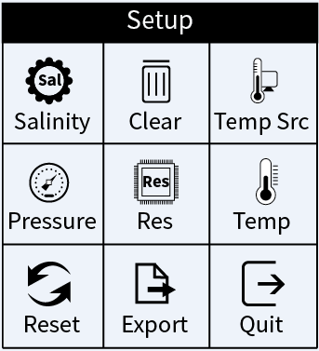
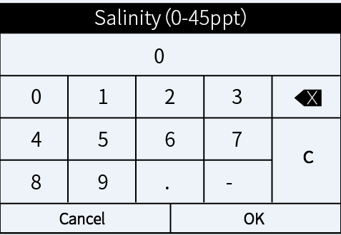

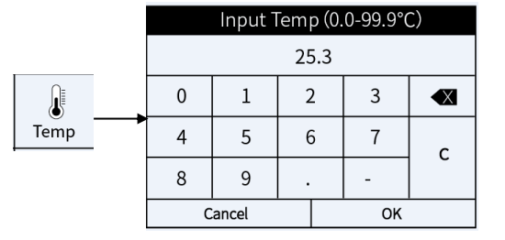

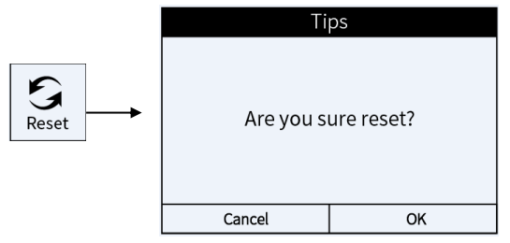
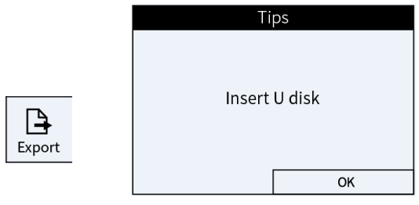

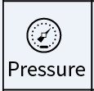

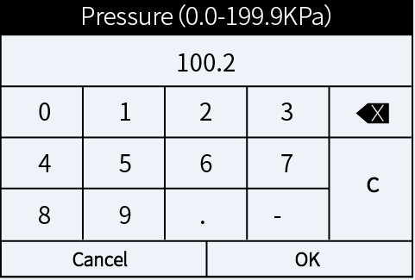

12.3 DO sub-Menu setup
（a）Salinity Compensation: Compensation by salinity （0-45ppt） Enter the salinity to be compensated for. click OK to save, click Cancel to return
（b）Clear records：Click clean to clean to data. Click cancel to return.
（c）Temp Src:“Manual”and“Automatic”,two options. then click OK to save, click Cancel to return.
（d）Pressure:Press Atmospheric Pressure Compensation to enter the compensation atmospheric pressure (0.0-199.9kPa), press OK to save the setting, press Cancel to return to the
（e）Resolution：0.1and 0.01；choose the suitable resolution，click OK to save the setting, click Cancel to return
（f）Manual Temperature：Manual temperature setup（0.0-99.9°）；
（g）Restore to factory default Setting：Restore to factory default Setting，Delete all the records；
（h）Records Input：Save records to the U disk.
（i）Exit : Press Exit to return to the test interface

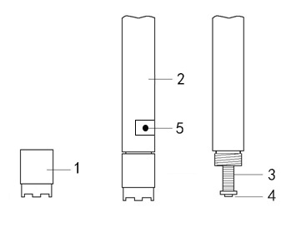
12.4 DO Calibration and Preparation
Preparation:
- Check on the DO electrode: see the Diagram right.
There should be no air bubbles in the electrode sensor cap.
If there is. Screw off the sensor cap, and refill DO electrolyte full.
(It is normal if there`s few DO electrolyte dripping during this process).
- Connect the DO electrode to the powered-on meter without measurement or calibrating. Let the electrode polarization consume the remaining oxygen inside the inner solution of the membrane cap so as to ensure fast response and high accuracy. The polarization time should be 15-30 minutes.
- DO sensor cap
- DO electrode shaft
- Anode (silver)
- Cathode (platinum)
- Temp. sensor
Full Saturated oxygen calibration
Place the dissolved oxygen electrode vertically in the air, the stability symbol changes from red to a smiley face and displays 100% full oxygen Calibration is complete, press OK to save the settings and Cancel to return to the
Zero oxygen calibration
Usually there is no need to do zero oxygen calibration unless you have a high requirement for accuracy in low oxygen level (<1.0ppm) or you are replacing the DO electrode, DO sensor cap, and long term not in use For zero oxygen calibration, follow the steps below：
- Prepare 100mL of zero-oxygen water: In a 100 mL beaker, add in 5.0g anhydrous sodium sulfite (Na₂SO₃) and distilled water to 100 mL, mix well to dissolve. Note that the zero-oxygen water is only effective within 24 hours.
- Polarize the meter for 15 minutes, and calibrate the meter as Clause 12.4 ；
- put the electrode into the oxygen-free water, press the calibration key the instrument enters the calibration mode, when the instrument displays the value ≤ 0.15mg/L (≤ 5min), the red dot turns into a smiley face, then press the OK key to calibrate, the calibration is completed in a few seconds, and the electrode will be rinsed clean with pure water
- If the reading is less than 0.02 ppm after 5 minutes, it means the electrode is in good condition and there is no need to perform zero oxygen calibration. Just press OK to return to measurement mode.
- If the reading is greater than 0.15 mg/L after 5min, it means that the response is slow and the residual current is large, the diaphragm cap can be replaced or the cap can be unscrewed, use polishing paper to lightly polish and gently wipe the surface of the platinum sheet of the cathode (to be wiped along the surface curvature of the platinum sheet), and then wipe the surface of the cathode with a clean velvet cloth or paper towel, wash the electrode with pure water and shake it dry. Then add some electrolyte into the diaphragm cap, reassemble and screw it tightly, and then calibrate the instrument for full saturated oxygen calibration and zero oxygen calibration.

12.5 DO Measurement
12.5.1water speed >5cm/s: Power on the meter, place the DO electrode into the flowing water. The water surface should be higher than the location of temperature sensor. The angel between the electrode and the water surface should be around 45° to 75°, Hold the electrode and get the readings when the smile icon stays on the screen (typically takes 3-5 minutes).
12.5.2 In the static water: Power on the meter, place the DO electrode into the flowing water，The water surface should be higher than the location of temperature sensor. The angel between the electrode and the water surface should be around 45° to 75°, move the electrode in water fast (>5cm/s) around 3-5 minutes. When the reading is fully stabilized, record the measurement (DO NOT stop the moving while recording the measurement).
12.5.3slower flowing water: follow the method in clause 12.5.1 but move the electrodes slightly faster.

12.6 Notes
- When calibration, the temperature difference between the sample solution and the air should be the close(≤10℃), If the temperature difference is too large, you can immerse the DO electrode in the sample water for about 10 minutes, and then perform the calibration immediately.
- The electrode requires polarization after each power on. Do not turn off the meter when in use.
- Temperature impacts the DO measurement significantly. When the electrode temperature and water temperature have larger difference, the reading time must be greater than 3 minutes. Otherwise, there could be some large errors.Especially when the difference between the electrode temperature and the water temperature is large, it is necessary to longer the reading time.
- Atmospheric pressure has a greater impact on the dissolved oxygen test (see attached table), the instrument has an automatic air pressure compensation function to ensure accuracy.
- Polarographic DO electrodes should not be tested in static water, as this will result in low values.。
- During measurement, air bubbles must not accumulate on the surface of the sensitive membrane of the dissolved oxygen electrode in contact with the water, otherwise it will affect the accuracy.
- There should be no air bubbles in the electrolyte inside the electrode (except for smaller bubbles), otherwise it will affect the corresponding speed and measurement accuracy. In case of larger air bubbles, the diaphragm cap should be screwed down and screwed up again after adding electrolyte.
- The sensitive film surface of the dissolved oxygen electrode should be kept wet to prevent the electrolyte at the cathode from drying out and affecting the electrode performance.
- Temperature electrode mounted on the dissolved oxygen electrode, the liquid level must exceed the height of the temperature when measuring, otherwise the temperature test is inaccurate leading to the final measurement results deviation is too large.
- When the meter performs abnormal, you can restore the meter to factory default settings, and conduct the calibration before measurement.

12.7 DO sensor cap replacement
When the DO electrode’s response time becomes slower, obvious errors occur in measurement, or when the sensitive membrane of DO electrode is wrinkled, cracked or damaged at any extent , it’s time to replace a new membrane cap according to the following steps.
- Screw off the membrane cap；
- Rinse the electrode without membrane cap with distilled water and shake-off excess water；
- Clean on the cathode surface (Platinum tablets) with a clean tissue；
- Add new inner solution into a new membrane cap slowly and do not let any air bubbles appear. If you found any air bubbles in the cap, carefully flick on the membrane cap to eliminate them.
- Place the membrane cap on the table and put in the electrode vertically, slowly twist in, and then screw on the cap tightly. The excess inner solution will be squeezed out. Please wipe it off with tissue and rinse off the electrode in distilled water.
- Check that there should be no air bubbles in the electrolyte (except smaller ones), otherwise it should be reassembled；
- When replacing the diaphragm cap, do not touch the sensitive membrane with your hands, so as to avoid the sweat and grease of the skin affecting the quality of the membrane and reducing the oxygen permeability.
Query、Save、Print： Refers to pH part

Warranty
The warranty covers (from delivery)：
We warrant the tester against defects in material and workmanship when used in a normal manner for a period of two (2) years (12 months to the electrode).
Note: The electrodes are consumables, and the service life depends on careful maintenance, usage conditions, frequency of use, etc. Within 12 months from delivery, if the user finds that the electrode cannot be used due to processing and manufacturing problems when unpacking it for use, it can be repaired or replaced free of charge.
The limited warranty does not cover the following:
- Wear and tear to parts.
- Accidental damage, as the pH bulb broken from shocking.
- Misuse, uncarefully handling.
- Unauthorized maintenance, soldering, counterfeiting and others.

Appendix：Troubleshooting
No. | Error | Reason | How to solve problem
1 | Can`t power on | No power on | After connecting the power, if the display does not light up, you should check whether there is voltage output from the power adapter.
1 | Can`t power on | The button is not responsive | Contact service providers
2 | Incorrect Temp. readings | No ATC，only MTC | Temperature thermistor failure，Replace electrode
3 | Abnormal temperature readings | Temperature about 2 times above normal | - For multi-parameter measurements, the temperature elements of the different modules are connected in parallel, so that all parameters can be temperature compensated by connecting to a single temperature electrode (Cond conductivity electrodes have built-in temperature elements).  - For multi-parameter measurements,separate the electrodes in different beakers to test the sample solution to avoid mutual interference.
4 | Strokes missing | LCD screen defective | Contact the supplier
5 | No change in all solution readings | Short circuit of electrode | - Replace the new electrode  - If no changes, contact the dealer for instrument repair
6 | Calibration failure | - Electrode damaged  - Incorrect/Expired calibration solution  - Electrodes not sufficiently wetted | - Replace the new electrode  - Check and replace new calibration solutions  - Rinse it into the pH/ORP socking solutions for 24 hours
7 | Numerical drift  or  Slow response and unstable | - Impurity adherence around the membrane/contamination of the ceramic junction  - Membrane aging  - Air bubbles exits in bulb | - Cleaning maintenance  - Replace a new electrode  - Flick the electrode to remove air from the bulb chamber
8 | the Conductivity Reads “0” | No current flow tested | - Front tip of the conductivity electrode should be completely immersed in the solution.  - When placing conductivity electrodes in solutions, avoid placing them in "dead" corners.  For the measurement of high-purified water, it must be measured in a flow cell, and the flow rate should not be too high.
9 | Err1 | Unstable reading | - Wait until the stable reminder symbol appears.

Appendix A：Content of Saturated Oxygen in water at different temperatures
Temp  ℃ | DO  mg/L | Temp  ℃ | DO  mg/L | Temp  ℃ | DO  mg/L
0 | 14.64 | 16 | 9.86 | 32 | 7.30
1 | 14.22 | 17 | 9.66 | 33 | 7.18
2 | 13.82 | 18 | 9.46 | 34 | 7.07
3 | 13.44 | 19 | 9.27 | 35 | 6.95
4 | 13.09 | 20 | 9.08 | 36 | 6.84
5 | 12.74 | 21 | 8.90 | 37 | 6.73
6 | 12.42 | 22 | 8.73 | 38 | 6.63
7 | 12.11 | 23 | 8.57 | 39 | 6.53
8 | 11.81 | 24 | 8.41 | 40 | 6.43
9 | 11.53 | 25 | 8.25 | 41 | 6.34
10 | 11.26 | 26 | 8.11 | 42 | 6.25
11 | 11.01 | 27 | 7.96 | 43 | 6.17
12 | 10.77 | 28 | 7.82 | 44 | 6.09
13 | 10.53 | 29 | 7.69 | 45 | 6.01
14 | 10.30 | 30 | 7.56
15 | 10.08 | 31 | 7.43

Appendix B：Content of Saturated Oxygen at different air pressure
Air pressure |  | DO（mg/L）
MmHg | kPa | 15℃ | 25℃ | 35℃
750 | 100.00 | 9.94 | 8.14 | 6.85
751 | 100.13 | 9.96 | 8.15 | 6.86
752 | 100.26 | 9.97 | 8.16 | 6.87
753 | 100.40 | 9.98 | 8.17 | 6.88
754 | 100.53 | 9.99 | 8.18 | 6.89
755 | 100.66 | 10.00 | 8.20 | 6.90
756 | 100.80 | 10.01 | 8.21 | 6.91
757 | 100.93 | 10.03 | 8.22 | 6.92
758 | 101.06 | 10.04 | 8.23 | 6.93
759 | 101.20 | 10.07 | 8.24 | 6.94
760 | 101.33 | 10.08 | 8.25 | 6.95
761 | 101.46 | 10.09 | 8.26 | 6.96
762 | 101.60 | 10.11 | 8.27 | 6.97
763 | 101.73 | 10.12 | 8.28 | 6.98
764 | 101.86 | 10.14 | 8.30 | 6.99
765 | 102.00 | 10.15 | 8.31 | 7.00
766 | 102.13 | 10.16 | 8.32 | 7.01
767 | 102.26 | 10.18 | 8.33 | 7.02
768 | 102.40 | 10.19 | 8.34 | 7.02
769 | 102.53 | 10.21 | 8.35 | 7.03
770 | 102.66 | 10.22 | 8.36 | 7.04
771 | 102.80 | 10.23 | 8.37 | 7.05
772 | 102.93 | 10.25 | 8.39 | 7.06
773 | 103.06 | 10.26 | 8.40 | 7.07
774 | 103.19 | 10.28 | 8.41 | 7.08
775 | 103.33 | 10.29 | 8.42 | 7.09

Appendix C: Content of Saturated Oxygen at different altitude

Altitude |  | Air pressure |  | DO | Altitude |  | Air pressure |  | DO
Foot | Meter | kPa | mmHg | mg/l | Foot | Meter | kPa | mmHg | mg/l
0 | 0 | 101.3 | 760 | 8.25 | 7500 | 2287 | 77.1 | 579 | 6.28
500 | 152 | 99.34 | 746 | 8.09 | 8000 | 2439 | 75.63 | 568 | 6.16
1000 | 305 | 97.6 | 733 | 7.95 | 8500 | 2591 | 74.44 | 559 | 6.06
1500 | 457 | 95.87 | 720 | 7.81 | 9000 | 2744 | 72.97 | 548 | 5.94
2000 | 610 | 94.28 | 708 | 7.68 | 9500 | 2896 | 71.64 | 538 | 5.83
2500 | 762 | 92.54 | 695 | 7.54 | 10000 | 3049 | 70.17 | 527 | 5.71
3000 | 915 | 90.95 | 683 | 7.41 | 10500 | 3201 | 68.84 | 517 | 5.61
3500 | 1067 | 89.35 | 671 | 7.28 | 11000 | 3354 | 67.38 | 506 | 5.49
4000 | 1220 | 87.75 | 659 | 7.15 | 12000 | 3659 | 66.58 | 500 | 5.42
4500 | 1372 | 86.15 | 647 | 7.02 | 13000 | 3963 | 65.78 | 494 | 5.36
5000 | 1524 | 84.56 | 635 | 6.89 | 14000 | 4268 | 64.98 | 488 | 5.29
5500 | 1677 | 83.09 | 624 | 6.77 | 15000 | 4573 | 64.18 | 482 | 5.23
6000 | 1829 | 81.63 | 613 | 6.65 | 16000 | 4878 | 63.38 | 476 | 5.16
6500 | 1982 | 80.03 | 601 | 6.52 | 17000 | 5183 | 62.58 | 470 | 5.10
7000 | 2134 | 78.56 | 590 | 6.40 | 18000 | 5488 | 61.79 | 464 | 5.03
Conversion of mmHg to kPa:
mmHg×0.13333=kPa
e.g.
200 mmHg = 200 × 0.133 = 26.6 kPa.
DO_{pt}=P×DO_{t}÷760

Note：
DO_{pt}— DO concentration under temperature t, air pressure P, mg/L;
P — air pressure, mmHg;
DO_{t} — DO concentration under temperature t, air pressure 760mmHg, mg/L;
760 — air pressure, mmHg.

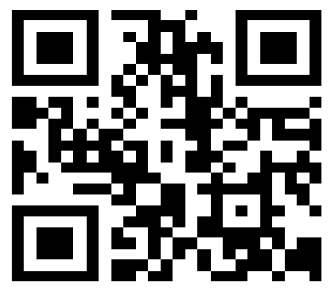
Drawell International Technology Limited

Shanghai Drawell Scientific Instrument Co.,Ltd.

Chongqing Drawell Instrument Co.,Ltd.

Add:Suite 2705,Building No.12,Shiyou Road No.1,Yuzhong District, Chongqing,China
Tel: 0086-023-63268643

Web : www.drawell.com.cn
Email : sales05@drawell.com.cn

