User Manual



Please read operating manual before installation and operation.

Drawell International Technology Limited
Shanghai Drawell Scientific Instrument Co.,Ltd

Add : Suite 1101,Lane561 XiuChuan Rd., Greeland Max-Mall,PuDong,Shanghai,China
Tel: 0086 21 50966080
Fax: 0086 21 50966080
Web : www.drawell.com.cn

LAMINAR FLOW CANBINET USER MANUAL

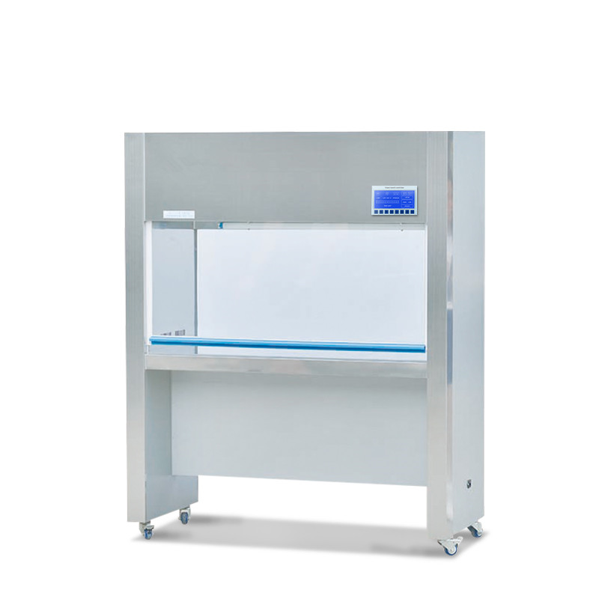

1.Brief introduction
It is widely used in medicine, pharmacy, biological & chemical experiment, electron, precise apparatus, instrument and so on.

Main Characteristics
- Equipped with spring up/down movable door in the front and back of work bench, flexible and convenient to locate,air insulation design to avoid cross pollution inside and outside
- Contact switch adjusts voltage to keep wind speed in working area in ideal state all the time.
- Operate with LED panel.
- The material of the work area is 304 stainless steel.

Model | SW-CJ-2D
Clean grade | Grade 100(209 E U.S. Federal)
Number of bacteria | ≤0.5per utensil.hour(90mm utensil)
Noise | ≤62dB
Power | 220V/50HZ
wind speed | 0.25-0.45m/s (slow,medium and fast 3 speeds)
illumination | ≥300LX
Working area dimension(W*D*H) | 1140*485*515mm
Overall dimension(W*D*H) | 1300*550*1600mm
HEPA filter size and quantity | 1135*460*38mm*1pc
Fluorescent/UV lamp specifications and quantity | 30W*1PC / 30W*1PC
Operator | two persons

2. Structural Characteristics
Laminar flow cabinet is made of several major components: the cabinet, fan and high efficiency filters, operating switches, etc. Box cold plate production, surface spray treatment, work tops, stainless steel. Purification unit uses a variable air volume fan system, by adjusting the fan working status, can the average wind speed to maintain a clean work area within the rated range, and effectively extend the life of the high efficiency filter.
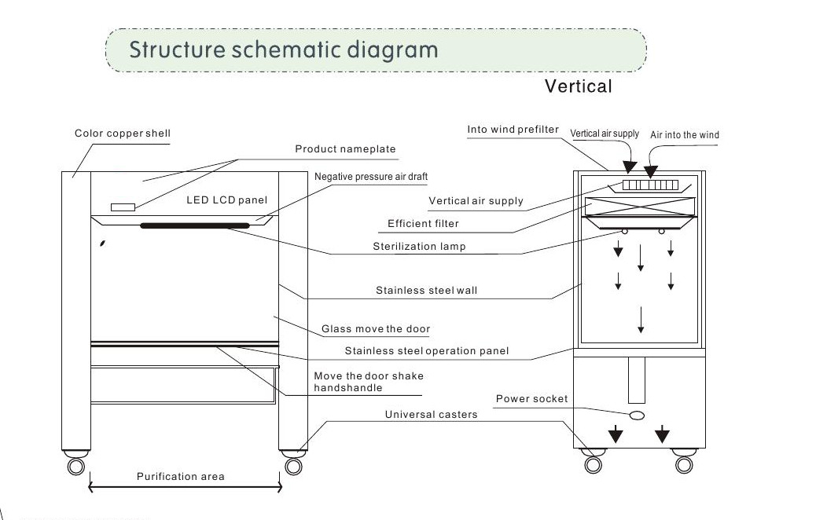
3.Working Principle
The Centrifugal fan pressure air through the primary filter, into the plenum chamber, and then after a hepa filtered from the blowing of the wind surface.Clean air flow to the uniform cross-section wind speed through the clean area, the region the dust away, thus forming a work environment of high cleanliness.

4. Schematic Diagram for Controller
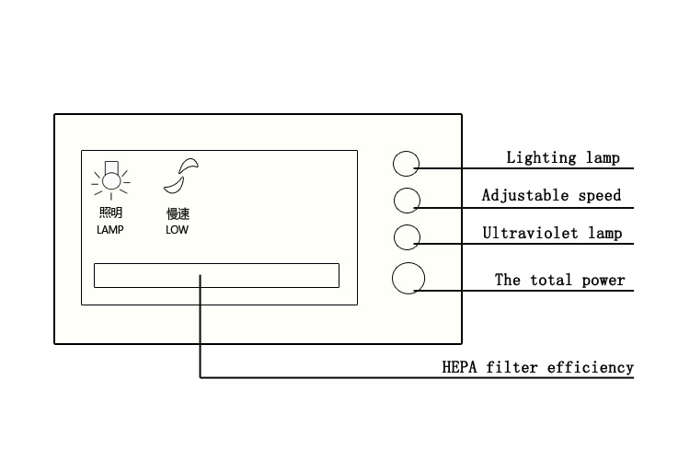
5. Installation
The laminar flow cabinet in place locations in the environment is relatively clean work room (preferably placed between the primary purification of one hundred thousand grade or three hundred thousand grade), plug in the power, as shown in function on the control panel to open the can, deal with purification workspace surface and shell before starting the carefully cleaning to remove surface dust, ten minutes after boot can be implemented normal operation.

6. Maintenance
- Based on actual usage, periodically remove the primary filter cleaning, the cleaning cycle is generally 3-6 months. (if not long-term cleaning, the dust will affect the amount of wind insufficient to reduce the cleaning effect.)
- When the early effect of the normal exchange or clean the filter air filter, still can not achieve the desired cross-section wind speed, then adjust the fan voltage, and thus achieve the desired uniform wind speed.
- Generally when the fan operating voltage adjustment to the highest point in the use of eighteen, still can not achieve the desired wind speed, description of the filter on the high efficiency filter dust too much (filter kong has basically stuck to timely update) general efficiency air filters use a period of eighteen months.
- Replacement of high efficiency air filters, should pay attention to the correctness of the model dimensions (original manufacturer configuration), arrow wind devices, and pay attention to the peripheral sealing of the filter is absolutely no leakage occurs.
7. General Failure, Causes, And Troubleshooting
Failure phenomenon | Reason | Remedy
Total power switch is not close automatically trip | 1.Fan stuck lead to motor stall,or short-circuit lines | 1.Adjust the fan air shaft position, or replace the impeller and bearings, check the line is intact.  2.The control circuit diagram, point by point inspection line components of the shell insulation resistance, and repair insulation failure.
Wind speed is low | 1.A primary filter too much dust.  2.The high efficiency filter failure. | 1.The beginning of the cleaning efficiency of the filter.  2.The replacement of high efficiency filter.
Fan does not turn | 1. The contact does not work.  2.The fan power fuse has blown. | 1. Check the contact line is normal.  2.Replace the fuse.
Fluorescent lamp is not lit | 1.A lamp or relay damage.  2.The lamp power supply fuse has blown. | 1.Replace the lamp or relay.  2. Replace the fuse.

Drawell International Technology Limited
Shanghai Drawell Scientific Instrument Co.,Ltd

Add : Suite 1101,Lane561 XiuChuan Rd., Greeland Max-Mall,PuDong,Shanghai,China
Tel: 0086 21 50966080
Fax: 0086 21 50966080
Web : www.drawell.com.cn

