User Manual

Dark box type
Four-way UV analyzer
DW-UVA-7



Please read operating manual before installation and operation.

Drawell International Technology Limited
Shanghai Drawell Scientific Instrument Co.,Ltd

Add : Suite 1101,Lane561 XiuChuan Rd., Greeland Max-Mall,PuDong,Shanghai,China
Tel: 0086 21 50966080
Fax: 0086 21 50966080
Web : www.drawell.com.cn
Email : sales01@drawell.com.cn
Thank you for purchasing the DW-UVA-7 quad with UV analyzer. The product manual includes the operation flow of instrument functions. To ensure the proper use of the instrument, please read the product instructions carefully before operating the instrument.
Security:
The following basic safety measures must be observed at all stages of operation, maintenance and instrumentation. When the instrument is used, it should be operated according to the instructions. Illegal use will cause the instrument to work normally and cause damage to the instrument.
In order to avoid electric shock, the input power cord of the instrument must be grounded. This instrument uses a three-core grounding plug. This plug has a grounding pin. If the plug can not be inserted into the seat, an electrician should be asked to install the correct socket. Don't let the instrument lose its earthing protection.
B, pay attention to the power supply:
Before connecting the AC power supply, ensure that the voltage is consistent with the voltage required by the instrument(allowing ± 10 % deviation) and that the rated load of the power socket is not less than the instrument requirements.
C, pay attention to the use of power cord:
This instrument usually uses randomly attached power lines. If the power cord is broken, it must be replaced and not repaired. Replace with a power cord of the same type and specification. No articles shall be placed on the power cord when this instrument is used. Do not place the power cord where people move.
D, pay attention to the placement of the instrument:
This instrument should be placed in a cool, ventilated, dry, dust-proof position. For better heat dissipation, the ventilation area of the instrument should maintain an effective distance(N<UNK> 30cm) from other items.
Overview:
The function of the ultraviolet analyzer is to be used for fluorescence analysis: when a material molecule in the ground state is exposed to excitation(ie, ultraviolet light), it absorbs the excited energy and the material molecule is in the excited state. The energy of the excited state molecule of the Jiapeng brand ultraviolet analyzer is partially consumed by vibration, so the molecule is in the vibration energy level. When the vibration energy level returns to the ground state, the excess energy is released in other forms as fluorescence, and different substances can emit different wavelengths. Fluorescence, People can judge the amount of different substances and content according to the strength and strength of different light colors.
1. in the scientific experimental work it is the detection of many major substances such as proteins, nucleotides and so on.
In drug production and research, it can be used to check the quality of various kinds of fluorescent drugs such as hormones, alkaloids, vitamins, etc.. It is particularly suitable for thin layer analysis, paper layer analysis and detection.
In the chemical industries such as rubber and petroleum in dye coatings, various fluorescent materials, fluorescent indicators and additives are determined to identify different types of crude oil and rubber products.
In textile chemical fiber, it can be used to determine different kinds of raw materials such as wool, silk synthetic fibers, cotton synthetic fibers, and can check the quality of the finished product.
5, in the grain, oil, vegetables, food sector can be used to check toxins,(such as aflatoxin, etc.) food additives, spoiled vegetables, fruits, cocoa beans, chocolate, fat, honey, sugar, eggs, etc. quality.
6, in the geology, archeology and other departments can be used to discover various minerals, to distinguish the authenticity of cultural relics fossils.
7, in the public security department can check the fingermark measurement, writing, etc..
8, agricultural products and food processing, storage, customs entry and exit, animal husbandry, scientific research, circulation and other fields of rapid on-site testing, or supermarkets, shopping malls, food quality control departments

Main technical performance:
Dark box type four-use ultraviolet analyzer DW-UVA-7 basic type: dark box built-in, wavelength 254, 302, 365 nm, visible light
Filter size: 200 X 80mm
UV lamp 6W × 4
Visible 4W × 1 branch

Usage:
1. The light emitted by the local ultraviolet lamp lamp filters out visible light through the filter, which provides strong ultraviolet rays of 254 nm and 365 nm for ultraviolet analysis.
2. Open the sample door, send the sample into the dark box, close the door, you can observe.
3. Connect the 220V power supply, press the switch to light the light, you can put the detection material under the light observation and analysis.
4. The ultraviolet light angle is adjustable, and there is a black knob on the right side. Its adjustable ability allows the light source to shine to any position in the dark box, and the left and right sides have an active operation port.
5. If you need to take a photo, place the digital camera at the camera mouth, adjust the aperture and focal length to start the photo(some models of this configuration are not standard)

Photo Description
1, plug in 220V power supply, ensure normal work. 2, place the sample in the dark box

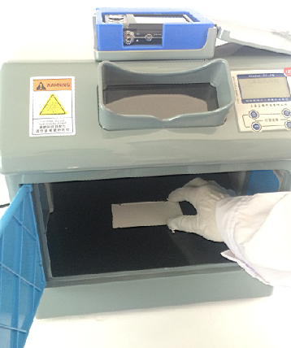
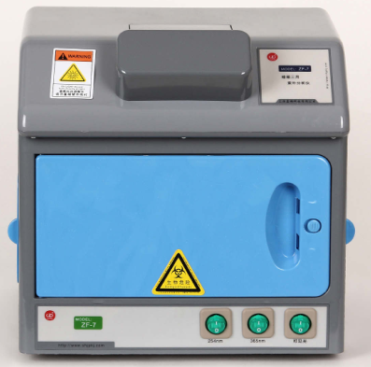

3、开启所需波长紫外灯，荧光产生 4、分析观察并操作

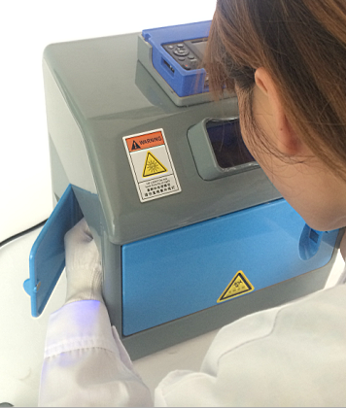
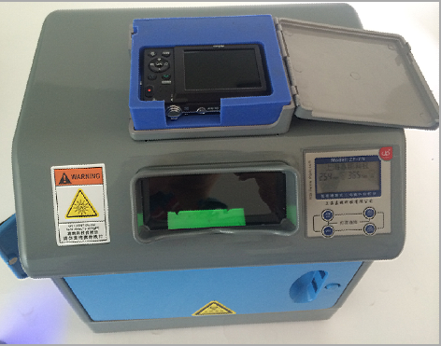

(The prototype of this manual is not necessarily the same as the model you purchased, but the operation method is the same, please know! ))

Drawell International Technology Limited
Shanghai Drawell Scientific Instrument Co.,Ltd

Add : Suite 1101,Lane561 XiuChuan Rd., Greeland Max-Mall,PuDong,Shanghai,China
Tel: 0086 21 50966080
Fax: 0086 21 50966080
Web : www.drawell.com.cn
Email : sales01@drawell.com.cn

